**Chapter 1**

**1. Introduction**

Our objective was to look at online retail from a customer’s point-of-view and determine which of the biggest ecommerce sites was providing the best customer experience.

1) To shop while in the comfort of your own home, without having to step out of the door   
2) To be able to easily save money and compare prices from website to website   
3) Online resellers tent to sell at a lower price due to less overhead expenses.

**1.1 Project Introduction**

The ShoppingBricks is the part of the sample application that provides customers with online shopping. Through a Web browser, a customer can browse the catalogue, place items to purchase into a virtual shopping cart. Create and sign in to a user account, and purchase the shopping cart contents by placing an order. After placing an order for selected items a user can make payment with through a credit card or through cash on delivery. There is no need to wait in long queue for purchase. Customer can purchase products sitting at home by viewing images of different category of products and adding in shopping cart.

ShoppingBricks will use some sort of shopping cart - this is a virtual trolley into which a person can place items, take them to the checkout when you want to pay. The checkout must be in a secure server in order for your transaction to be secure (in case of card payment).

**1.2 Problem Description**

**Problems/Needs**

* Time Consuming process
* Difficulty to finding the products
* Inconvenient
* Difficult to compare prices
* High Price
* Limited Products
* Limited operation period
* Less information about the product.

**Solutions/Approach**

These steps will be considered to solve above mentioned problems

* Do not have to spend time to travel.
* Easy to find any product you want by simply browsing the website.
* Convenience
* Easy to compare product and prices
* Discounts are available
* Available 24x7
* Broader product Range
* Quality of information about the product

**1.3 About Organisation**

Company Name: - Apex TG India Pvt. Ltd.

Company Address: - E-20, E-Block, Sec-63, Noida-201307, UP

Apex TG India Pvt. Ltd. focuses on delivering sophisticated technology-enabled solutions, consulting and Training to maximize complex business needs. Founded in 2007 and based in New Delhi NCR Noida. We deal in IT Consulting, Training and Development services and providing substantial and concrete results to the clients from across the globe. We provide technical, management and personal skills development, focused on developing better brains for better business.

**Chapter 2**

**2. System Study**

A detailed system to determine whether, to what extent, and how automatic data-processing equipment should be used. It usually includes an analysis of the existing System and the design of the new system, including the development of systemspecifications which provide a basis for the selection of equipment.

**2.1 Existing System with limitations**

Here are the top disadvantages and limitations of e-commerce businesses:

1. **Security**

One of the main limitations of e-commerce is security. In most cases, people are hesitant to provide their personal and financial details in spite of advanced data encryption security systems in place.

**2. Lack of Privacy**

To some extent, the privacy of a customer is compromised in e-commerce. You need to provide your personal details, such as address, telephone number, and so on to the seller.

**3. Product Suitability**

As already mentioned, it is not possible for people to physically examine the product in e-commerce. In many cases, the original product may not match with the picture or specifications in the e-commerce site. This absence of ‘touch and feel’ creates a discouraging effect.

**4. Technical Limitations**

 e-commerce requires advanced technology platforms for better performance. Some limitations, such as lack of proper domain, network and software issues and so on can affect the seamless performance of an e-commerce site.

**5.** **Huge Technological Cost**

  Last but not the least; a lot of money needs to be invested to be built up the technical infrastructure needed to run an e-commerce business. Moreover, they need to be upgraded based to keep abreast with the changing technology.

**2.2 Proposed System with Objectives**

Our objective was to look at online retail from a customer’s point-of-view and determine which of the biggest ecommerce sites was providing the best customer experience.

1) To shop while in the comfort of your own home, without having to step out of the door   
2) To be able to easily save money and compare prices from website to website   
3) Online resellers tent to sell at a lower price due to less overhead expenses.

The aim and objectives of ShoppingBricks are as follows:

1. Make a profit

2. Survive as a business

3. Provide the quality of a product

4. Increase the market share

5. Expand sales of profits and expand into new areas of the city

6. Improve the quality of a product

7. Be environmental friendly

8. To satisfy customers by providing excellent customer service and quality of products.

9. To be competitive with the competition around us for achieving a better status.

**2.3 Feasibility Study**

**2.3.1 Economical**

Economic analysis is the most frequently used method for evaluating the candidate system. More commonly known as Cost Benefit Analysis, the procedure is to determine the benefits and savings of the candidate system and compare them with the costs.

The economic feasibility for the proposed system is reasonably fair. This project does not have many hardware requirements and also the no of people required for this system is less than that of the manual system, thus, it requires less costing to install the software overall.

**2.3.2 Technical**

The technical feasibility tests are conducted to study the functional performance and constraints that may affect the ability of the new proposed system.

In this phase, we think and analyze about the technical requirement of a product and we try to find out the answer of a question that whether our project is technically feasible or not.

The following questions were asked during the study:

**1.** Is the proposed technology or solution practical?

**2.** Do we currently pass the necessary technical expertise?

**3.** How many systems are required?

**4.** Is the project has ability to producing the result in a fine time span.

**5.** The proposed system must be responsible for reliability of database.

**6.** One more aspect, which is worth for discussion, is security and reliability of the new system.

**7.** Since the proposed system is designed to run on computers, there is every bit possibility that any unauthorized user can modify the data. Hence, great care has been taken so that only authorized user can have access. For creating reliable & secure database, we have used SQL Server database as a backend tool.

**2.3 Duration**

The project duration is of six months. The whole development process of our project is starting from January to till June.

**Chapter 3**

**3. System Analysis**

|  |  |  |
| --- | --- | --- |
| Sr. NO | Description | Notes |
| 1 | User Requirements | Step by step Report: Excellent Planning. Organization and management. To avoid the conflicts you can analyze the effects easily in response to particular action. |
| 2 | Functional requirements | 1. Modules for admin to handle the administration task. 2. Module for user to manage user information. 3. Modules to manage product category and information 4. Module for managing roles and menus. 5. Module to Place online order 6. Modules for users to select the products, add products to the cart, make payments. |
| 3 | Reporting Requirements | Users can get reports of the ordered products from the admin as a mail. |
| 4 | Security Requirements | Data Security: Proper Backup of data   * The access to the system must be through the secure and authenticated login, authorizations, etc. |
| 5 | Non-Functional requirements | * Secure access of confidential by using roles based authentication. * 24 X 7 availability. * Better component design to get better performance at peak. |

**3.1 System Flowchart**

Flow Charts are the Pictorial representations of the flow of the data of the Travel with Glance System. In flowcharts the Start/Stop is represented by eclipse, Input/output is shown by rectangles, operations are shown in parallelogram, and diamonds represents the Decision box.

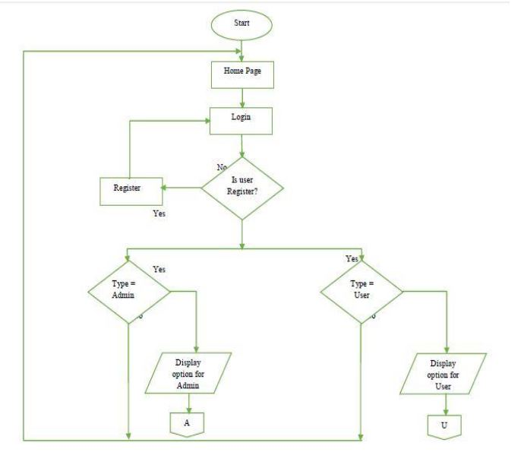

**Figure 1- Flow chart of our project “ShoppingBricks”**

**3.2 E-R Diagrams**

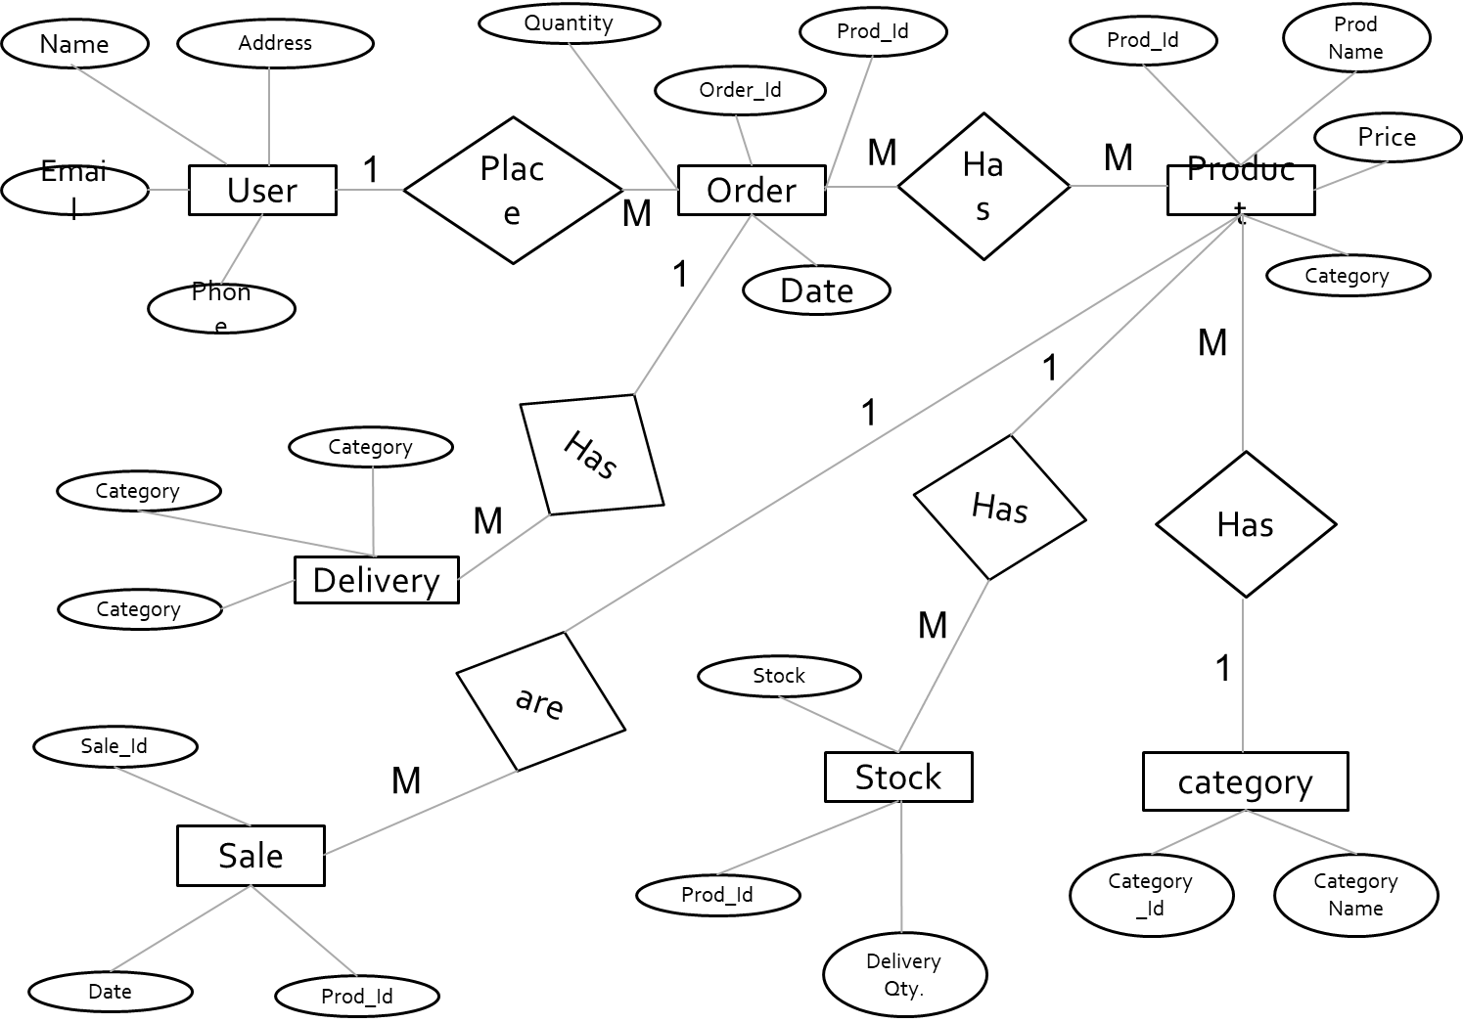

**Figure 2- An Entity-Relationship(ER) Diagram of ShoppingBricks**

**3.4 Data Flow Diagram(DFD)**

A DFD has the purpose of clarifying system requirements and identifying major transformation means how data is flowing at various level between source destinations. A DFD consist of a series of bubbles Joint by lines. The bubbles represent data transformation and the lines represent data flow.

The DFD is one of the most important tools to be used by system analyst. The main merit of DFD is that can provide an overview of what files are used, and where the results flow. The graphical representation of the system makes it a good communication tool between a user and an analyst. Symbols used in making data flow diagram are: -

**1.Circle or a Bubble: -**

It represents a process that transforms incoming data flows into outgoing data flows.

**Symbol-**

**2.Rectangle: -**

A rectangle represents an external entity, situated outside the system. Entity supplying data are known as **sources** and those that consume data are called **sinks.**

**Symbol-**

**3.An Arrow: -**

An arrow identifies data flow. It also represents data in motion. It is a pipeline through which information flows.

**Symbol-**

**0 Level or Context Level DFD**



**Figure 3- System Level Data Flow Diagram**

**Level 1 Data Flow Diagram**

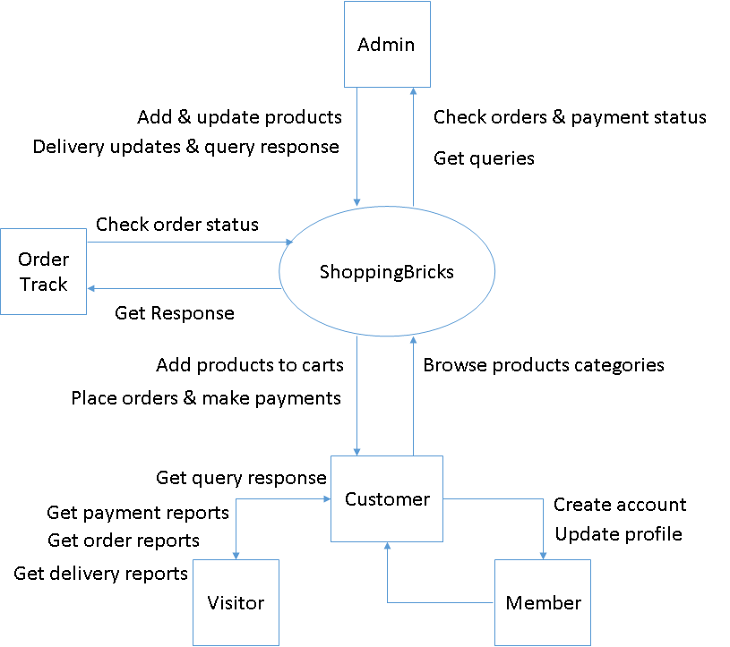

**Figure 4- Level 1 DFD of ShoppingBricks**

**Level 2 Data Flow Diagram**

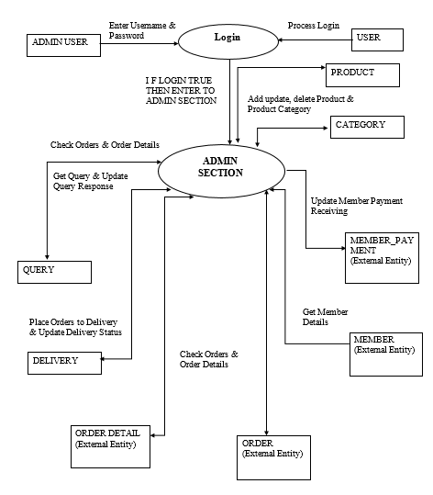

**Figure 5- Level 2 DFD**

**3.4 Requirement Specifications**

Minimum requirements for project development are as follows-

**FRONT END**

i) Presentation Layer: **Java Server Pages**

* User friendly
* Separation of work (design and coding)
* Write once and run anywhere

ii) Middle tier: **Java Beans and Servlet.**

iii) Database Layer: **MySQL**

iv) Web development language: HTML5, CSS, and BOOTSTRAP.

**SOFTWARE REQUIREMENTS**

* Windows 10/Windows 8
* MySQL
* JSP & Java
* Apache Tomcat Server
* Hibernate & Spring Framework
* Eclipse Oxygen IDE
* Google Chrome or Microsoft Edge browser.

**HARDWARE REQUIREMENTS**

* Intel Core i3 2GHz Processor
* 4 GB RAM
* 10 GB Hard Disk

**PACKAGES**

* com.shoppingbricks.web
* com.sun.tools.javac.main
* com.shoppingbricks.cart.model
* com.shoppingbricks.login

**Chapter 4**

**4. System Design**

The system design is not a step adherence of clear procedures and guidelines. Through certain clear procedures and guidelines have emerged in recent days, but still much of design work depends on knowledge and experience of the designers.

. More clear defined logical method for developing system that meets user requirements that has led to new techniques and methodology that fundamentally attend to do the following: -

* Improve productivity of analyst and programmer.
* Improve documentation which means subsequent enhancements.
* Cut down drastically on cost over runs and delays.
* Improve communications among the users, analyst, designers, and programmers.
* Standardize the approach to analysis and design.
* Simplify design by segmentation.

Software function overview: -

In the existing manual system, the overall working process is performed manually. The conversion of the manual system into an automated one is replaced by a table in the SQL Server. Input format has changed into interactive input forms and validations. The process has automated for relieving the user from a critical burden.

**4.1 Modular Design**

Project is divided into following modules-

**A. ADMIN MODULE**

Admin can perform following tasks:

a) Add/Remove Products

b) Update Product information

c) Access the Database

d) Add/Block Users

**B. USER MODULE**

Users can perform the following task:

a) Signup

b) Sign In

c) Change Password

d) Request for password from Admin if forgot the password.

f) Browse products/View products

g) Select the products and Add to Cart

h) Place Order

i) Make Payment

**C. VISTORS**

a) Browse the web sites

b) View the products

**4.2 Context Diagram**

A context diagram in engineering is a diagram that defines the boundary between the system, or part of a system, and its environment, showing the entities that interact with it. This diagram is a high level view of a system. It is similar to a block diagram.

The context level diagram of ShoppingBricks is below-



**Figure 6- System Level Context Diagram**

**4.3 Structure Chart**

1. Structure chart for Customer activities are mentioned below-

ShoppingBricks

Customer

Product

Order

Payment

Account

Search

View

Add to cart

Add

Delete

Update

View

Confirm

Check

Registration

Login

**Figure 6- Structure Chart for Customer Activities of ShoppingBricks**

2. Structure chart for Administrator activities is mentioned below-

ShoppingBricks

Administrator

Order

Product

Payment

Delivery

Delete

View

Shipment

Add

Delete

Update

View

Collect

Check

Report Check

Check Status

**Figure 7- Structure chart for Administrator activities.**

**4.4 Database Design**

1- ad_user table

|  |  |  |
| --- | --- | --- |
| ***Name*** | ***Data Type*** | ***Constraints*** |
| ***aname*** | ***varchar*** | ***Not Null*** |
| ***aemail*** | ***Varchar*** | ***Not Null*** |
| ***regdate*** | ***Varchar*** | ***Not Null*** |

2- address table

|  |  |  |
| --- | --- | --- |
| ***Name*** | ***Data Type*** | ***Constraints*** |
| ***adid*** | ***Int*** | ***Primary Key*** |
| ***emailid*** | ***Varchar*** | ***Not Null*** |
| ***address1*** | ***Varchar*** | ***Not Null*** |
| ***address2*** | ***Varchar*** | ***Not Null*** |
| ***landmark*** | ***Varchar*** | ***Not Null*** |
| ***City*** | ***Varchar*** | ***Not Null*** |
| ***State*** | ***Varchar*** | ***Not Null*** |
| ***pincode*** | ***Varchar*** | ***Not Null*** |
| ***Userid*** | ***Varchar*** | ***Not Null*** |
| ***Ordered*** | ***Varchar*** | ***Not Null*** |

3. admin table

|  |  |  |
| --- | --- | --- |
| ***Name*** | ***Data Type*** | ***Constraints*** |
| ***Admin_name*** | ***Varchar*** | ***Primary Key*** |
| ***Admin_pwd*** | ***Varchar*** | ***Not Null*** |

4. demo table

|  |  |  |
| --- | --- | --- |
| ***Name*** | ***Data Type*** | ***Constraints*** |
| ***Id*** | ***int*** | ***Primary Key*** |
| ***Name*** | ***Varchar(max)*** | ***Not Null*** |
| ***Amount*** | ***int*** | ***Not Null*** |
| ***Password*** | ***Varchar(max)*** | ***Not Null*** |

5. p_subcat table

|  |  |  |
| --- | --- | --- |
| ***Name*** | ***Data Type*** | ***Constraints*** |
| ***P_subcatId*** | ***int*** | ***Primary Key*** |
| ***pcatId*** | ***Int*** | ***Not Null*** |
| ***Pcname*** | ***Varchar*** | ***Not Null*** |
| ***P_subcatName*** | ***Varchar*** | ***Not Null*** |

6. payment_details table

|  |  |  |
| --- | --- | --- |
| ***Name*** | ***Data Type*** | ***Constraints*** |
| ***Pay_Id*** | ***int*** | ***Primary Key*** |
| ***Card_holder_name*** | ***Varchar*** | ***Not Null*** |
| ***Card_number*** | ***Varchar*** | ***Not Null*** |
| ***Cvv_code*** | ***Varchar*** | ***Not Null*** |
| ***Month_start*** | ***Varchar*** | ***Not Null*** |
| ***Year_start*** | ***Varchar*** | ***Not Null*** |

7. post table

|  |  |  |
| --- | --- | --- |
| ***Name*** | ***Data Type*** | ***Constraints*** |
| ***Posttitle*** | ***Varchar*** | ***Not Null*** |

8. prod_cat table

|  |  |  |
| --- | --- | --- |
| ***Name*** | ***Data Type*** | ***Constraints*** |
| ***Pcat_Id*** | ***int*** | ***Primary Key*** |
| ***Pc_Name*** | ***Varchar*** | ***Not Null*** |

9. product table

|  |  |  |
| --- | --- | --- |
| ***Name*** | ***Data Type*** | ***Constraints*** |
| ***Pcat_Id*** | ***int*** | ***Not Null*** |
| ***Psubcat_Id*** | ***Varchar*** | ***Not Null*** |
| ***Posttitle*** | ***Varchar*** | ***Not Null*** |
| ***Pid*** | ***Int*** | ***Primary Key*** |
| ***pname*** | ***Varchar*** | ***Not Null*** |
| ***Pcompid*** | ***Int*** | ***Not Null*** |
| ***Pcomp_name*** | ***Varchar*** | ***Not Null*** |
| ***Pcname*** | ***Varchar*** | ***Not Null*** |
| ***Psubcat_name*** | ***Varchar*** | ***Not Null*** |
| ***Pimg_url*** | ***Varchar*** | ***Not Null*** |
| ***Pdesc*** | ***Varchar*** | ***Not Null*** |
| ***Price*** | ***Int*** | ***Not Null*** |
| ***P_quantity*** | ***Int*** | ***Not Null*** |
| ***Post_date*** | ***Date*** | ***Not Null*** |
| ***pmodel*** | ***varchar*** | ***Not Null*** |

10. product_company table

|  |  |  |
| --- | --- | --- |
| ***Name*** | ***Data Type*** | ***Constraints*** |
| ***Pcom_Id*** | ***int*** | ***Primary Key*** |
| ***pc_id*** | ***Int*** | ***Not Null*** |
| ***Pcom_name*** | ***Varchar*** | ***Not Null*** |

11. purchase_history table

|  |  |  |
| --- | --- | --- |
| ***Name*** | ***Data Type*** | ***Constraints*** |
| ***Ph_id*** | ***int*** | ***Primary Key*** |
| ***Uid*** | ***Int*** | ***Not Null*** |
| ***Pid*** | ***int*** | ***Not Null*** |

12. shipping_address table

|  |  |  |
| --- | --- | --- |
| ***Name*** | ***Data Type*** | ***Constraints*** |
| ***Ship_Id*** | ***int*** | ***Primary Key*** |
| ***Email_id*** | ***Varchar*** | ***Not Null*** |
| ***Address1*** | ***Varchar*** | ***Not Null*** |
| ***Address2*** | ***Varchar*** | ***Not Null*** |
| ***Landmark*** | ***Varchar*** | ***Not Null*** |
| ***City*** | ***Varchar*** | ***Not Null*** |
| ***State*** | ***Varchar*** | ***Not Null*** |
| ***Pincode*** | ***Varchar*** | ***Not Null*** |
| ***Userid*** | ***Int*** | ***Not Null*** |
| ***orderid*** | ***Varchar*** | ***Not Null*** |

13. users table.

|  |  |  |
| --- | --- | --- |
| ***Name*** | ***Data Type*** | ***Constraints*** |
| ***Id*** | ***int*** | ***Primary Key*** |
| ***UserName*** | ***Varchar*** | ***Not Null*** |
| ***Password*** | ***Varchar*** | ***Not Null*** |
| ***Cpass*** | ***Varchar*** | ***Not Null*** |
| ***Email_address*** | ***Varchar*** | ***Not Null*** |
| ***phone*** | ***Varchar*** | ***Not Null*** |

**4.5 Input/output Form Design**

**Input Form Design: -**

In an information system, input is the raw data that is processed to produce output. During the input design, the developers must consider the input devices such as PC, MICR, OMR, etc.

Therefore, the quality of system input determines the quality of system output. Well-designed input forms and screens have following properties −

* It should serve specific purpose effectively such as storing, recording, and retrieving the information.
* It ensures proper completion with accuracy.
* It should be easy to fill and straightforward.
* It should focus on user’s attention, consistency, and simplicity.
* All these objectives are obtained using the knowledge of basic design principles regarding −
  + What are the inputs needed for the system?
  + How end users respond to different elements of forms and screens.

Objectives for Input Design

The objectives of input design are −

* To design data entry and input procedures
* To reduce input volume
* To design source documents for data capture or devise other data capture methods
* To design input data records, data entry screens, user interface screens, etc.
* To use validation checks and develop effective input controls.

Data Input Methods

It is important to design appropriate data input methods to prevent errors while entering data. These methods depend on whether the data is entered by customers in forms manually and later entered by data entry operators, or data is directly entered by users on the PCs.

A system should prevent user from making mistakes by −

* Clear form design by leaving enough space for writing legibly.
* Clear instructions to fill form.
* Clear form design.
* Reducing key strokes.
* Immediate error feedback.

Some of the popular data input methods are −

* Batch input method (Offline data input method)
* Online data input method
* Computer readable forms
* Interactive data input

**Output Form Design: -**

The design of output is the most important task of any system. During output design, developers identify the type of outputs needed, and consider the necessary output controls and prototype report layouts.

### Objectives of Output Design

The objectives of input design are −

* To develop output design that serves the intended purpose and eliminates the production of unwanted output.
* To develop the output design that meets the end user’s requirements.
* To deliver the appropriate quantity of output.
* To form the output in appropriate format and direct it to the right person.
* To make the output available on time for making good decisions.

Let us now go through various types of outputs −

### External Outputs

Manufacturers create and design external outputs for printers. External outputs enable the system to leave the trigger actions on the part of their recipients or confirm actions to their recipients.

Some of the external outputs are designed as turnaround outputs, which are implemented as a form and re-enter the system as an input.

### Internal outputs

Internal outputs are present inside the system, and used by end-users and managers. They support the management in decision making and reporting.

There are three types of reports produced by management information −

* **Detailed Reports** − They contain present information which has almost no filtering or restriction generated to assist management planning and control.
* **Summary Reports** − They contain trends and potential problems which are categorized and summarized that are generated for managers who do not want details.
* **Exception Reports** − They contain exceptions, filtered data to some condition or standard before presenting it to the manager, as information.

### Output Integrity Controls

Output integrity controls include routing codes to identify the receiving system, and verification messages to confirm successful receipt of messages that are handled by network protocol.

Printed or screen-format reports should include a date/time for report printing and the data. Multipage reports contain report title or description, and pagination. Pre-printed forms usually include a version number and effective date.

**4.7 Screen Design**

Many online data entry devices are CRT screens that provide instant visual verification of input data and a means of prompting the operator. Operator can make any changes desired before the data go to the system processing. A CRT screen is actually a display station that has a b (memory) for storing data. A common size display is 24 rows of 80 characters each or 1,920 characters.

There are two approaches to designing data on CRT screens: in. and software utility methods. The manual method uses a work sheet m like a print layout chart. The menu or data to be displayed are blocked in the areas reserved on the chart and then they are incorporated into system to formalize data entry. For example, in the first command in the partial program is interpreted by system as follows: "Go to row 10 and column 10 on the screen and display (SAY) the statement typed between quotes." The same applies to the three commands. The command "WAIT TO A" tells the system to keep menu on the screen until the operator types the option next to the word.

"WAITING."

The main objective of screen display design is simplicity for accurate and quick data capture or entry. Other guidelines are:

   1. Use the same format throughout the project.

   2. Allow ample 3pace for the data. Overcrowding causes eye strain and may tax the interest of the user.

   3.Use easy-to-Iearn and consistent terms, such as "add," "delete,' and "create."

   4. Provide help or tutorial for technical terms or procedures.

The second approach to designing screen layouts is through so utility, usually provided by the CRT vendor. For example, IBM provides a screen Design Aid (SDA) package that allows the designer (at the terminal) to modify the display components.

**Chapter 5**

**5. System Implementation**

**Systems implementation** is the process of:

1. defining how the information system should be built (i.e., physical system design),
2. ensuring that the information system is operational and used,
3. ensuring that the information system meets quality standard (i.e., quality assurance).

**5.1 H/W & S/W Requirements**

Minimum requirements for developing our project “**ShoppingBricks**” are listed below-

**FRONT END**

i) Presentation Layer: **Java Server Pages**

* User friendly
* Separation of work (design and coding)
* Write once and run anywhere

ii) Middle tier: **Java Beans and Servlet.**

iii) Database Layer: **MySQL**

iv) Web development language: HTML5, CSS, and BOOTSTRAP.

**SOFTWARE REQUIREMENTS**

* Windows 10/Windows 8
* MySQL
* JSP & Java
* Apache Tomcat Server
* Hibernate & Spring Framework
* Eclipse Oxygen IDE
* Google Chrome or Microsoft Edge browser.

**HARDWARE REQUIREMENTS**

* Intel Core i3 2GHz Processor
* 4 GB RAM
* 10 GB Hard Disk

**PACKAGES**

* com.shoppingbricks.web
* com.sun.tools.javac.main
* com.shoppingbricks.cart.model
* com.shoppingbricks.login

**5.2 User Interface Design**

User interface is the front-end application view to which user interacts in order to use the software. User can manipulate and control the software as well as hardware by means of user interface. Today, user interface is found at almost every place where digital technology exists, right from computers, mobile phones, cars, music players, airplanes, ships etc.

User interface is part of software and is designed such a way that it is expected to provide the user insight of the software. UI provides fundamental platform for human-computer interaction.

UI can be graphical, text-based, audio-video based, depending upon the underlying hardware and software combination. UI can be hardware or software or a combination of both.

The software becomes more popular if its user interface is:

* Attractive
* Simple to use
* Responsive in short time
* Clear to understand
* Consistent on all interfacing screens

**Here are some UI (snapshots) of ShoppingBricks: -**

**1. Home page of website**

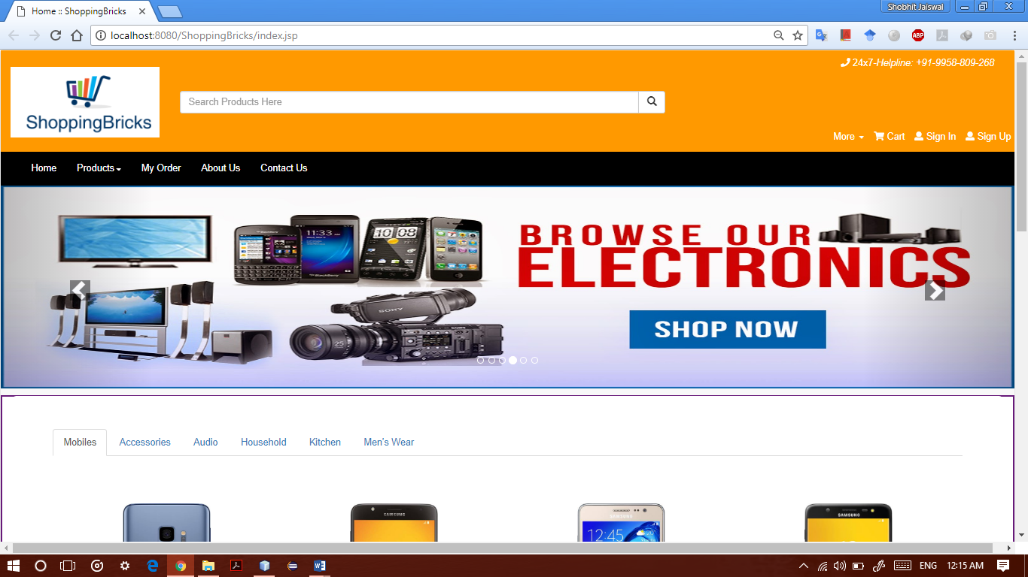

**2. Signup Form**

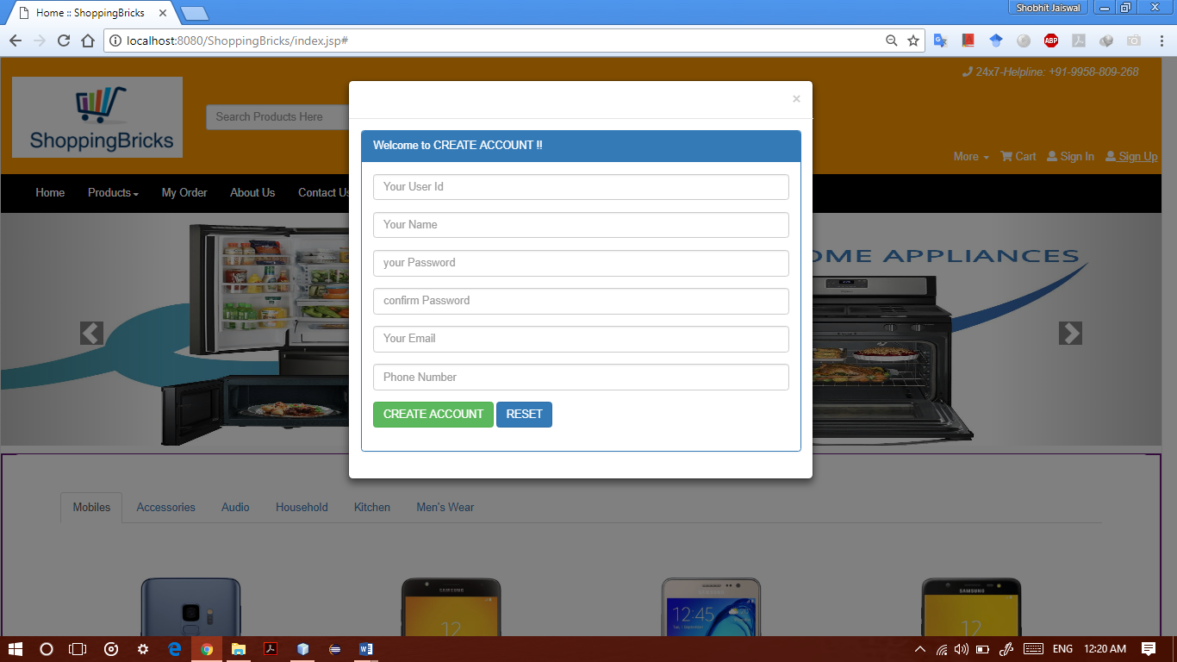

**3. Login Form**

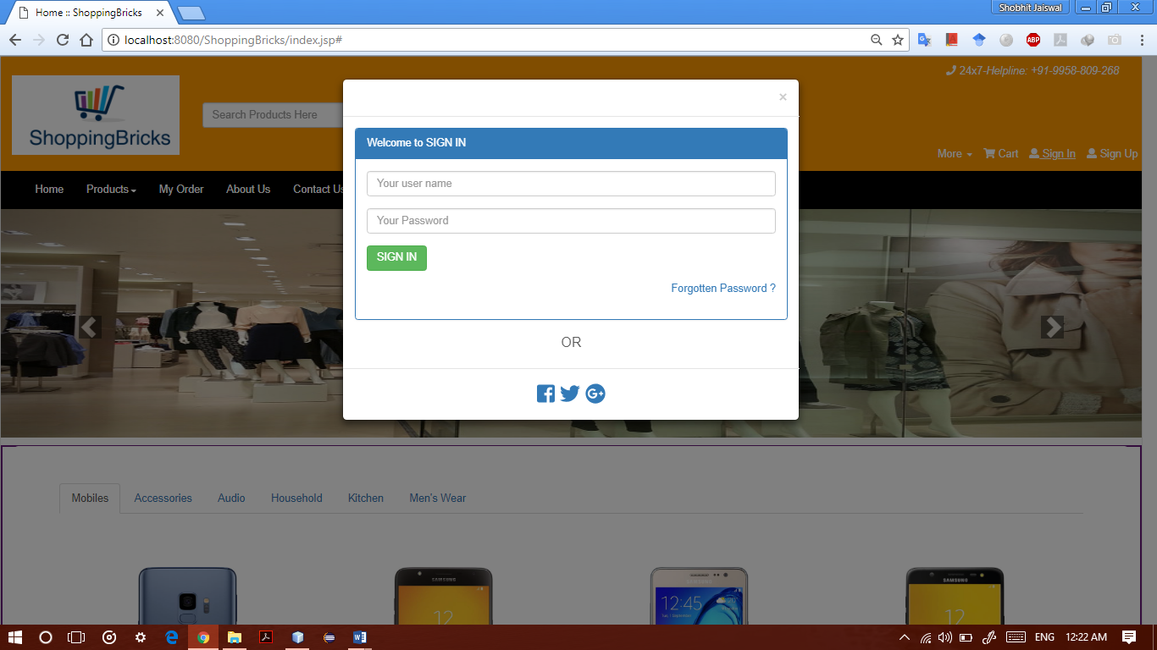

**4. Website About us page**

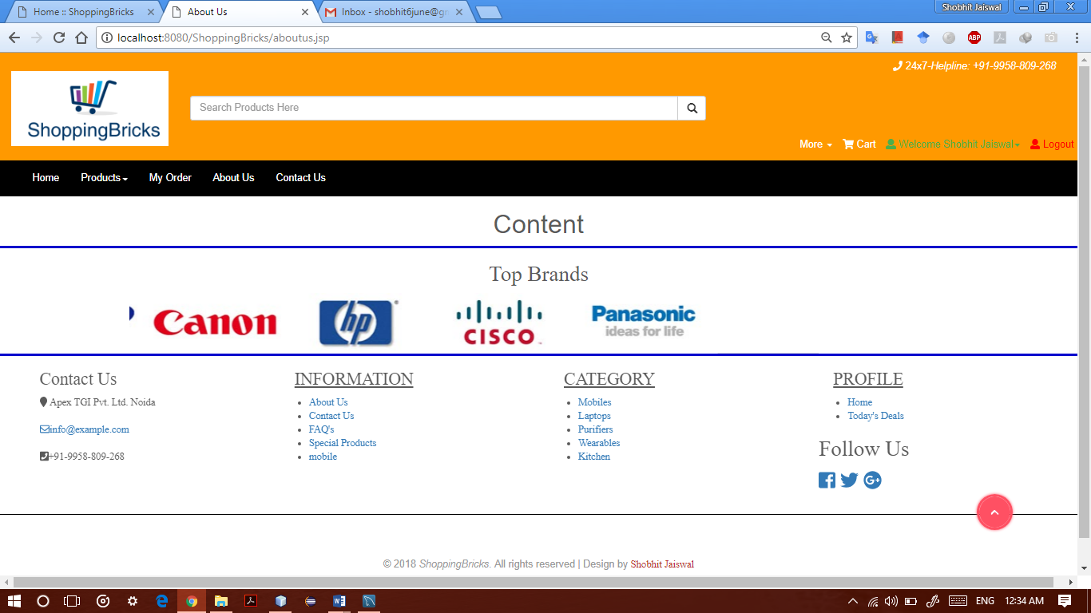

**5. Contact us page**

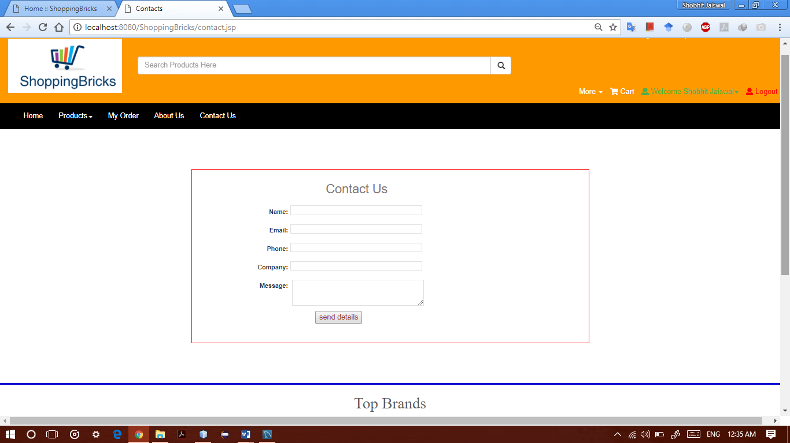

**6. View cart page**

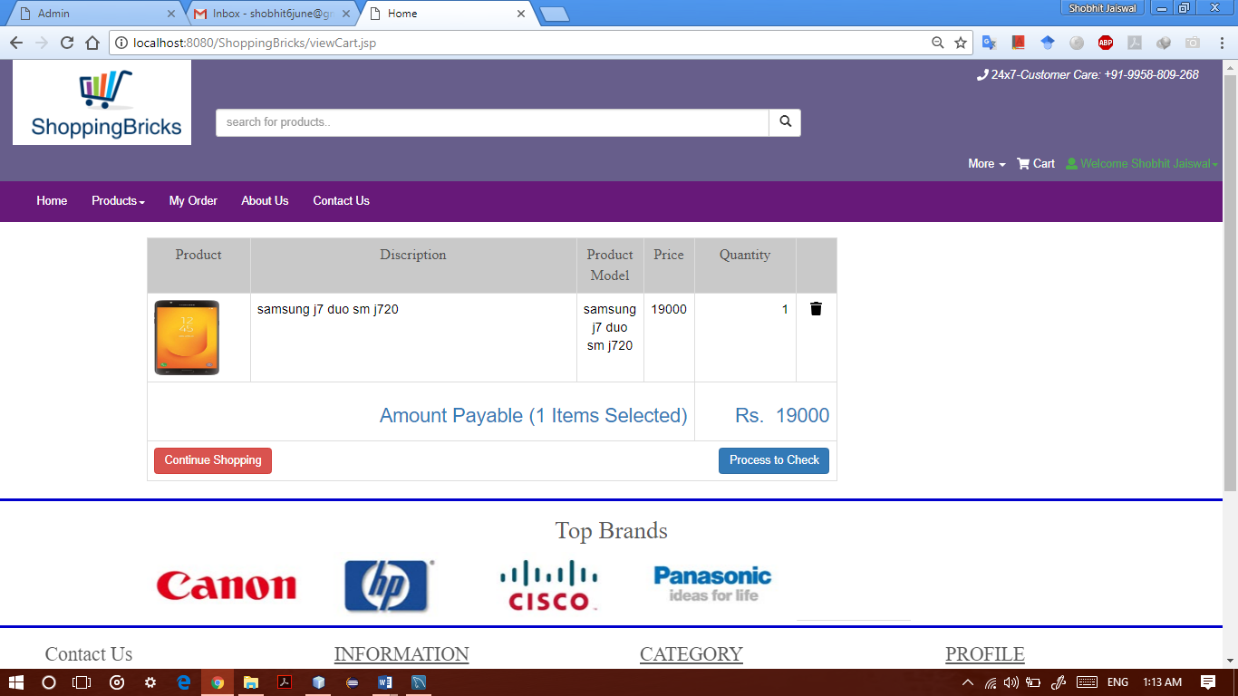

**7. Product Checkout page**

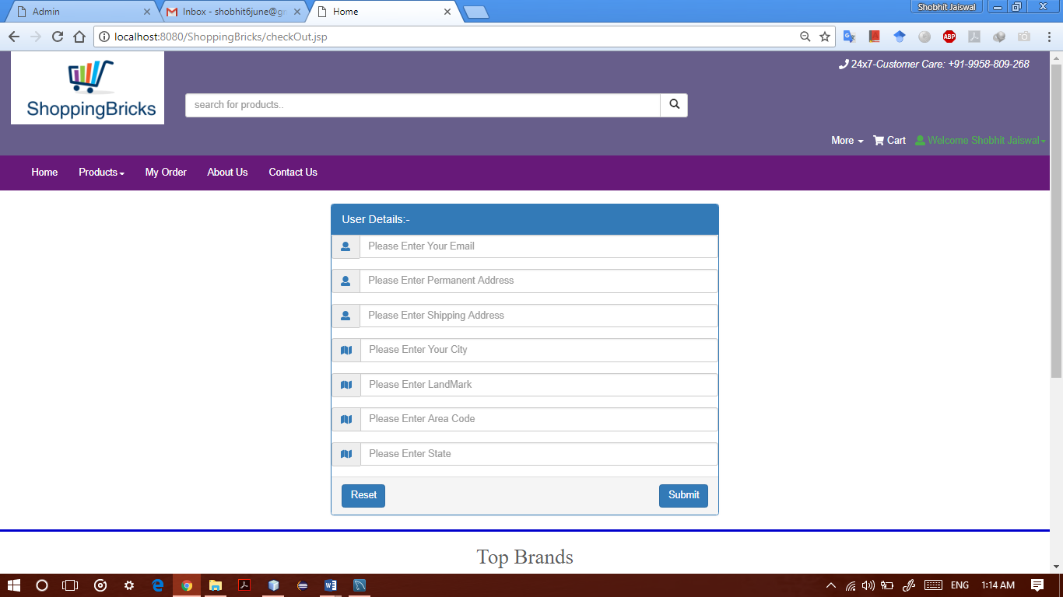

**8. Payment page**

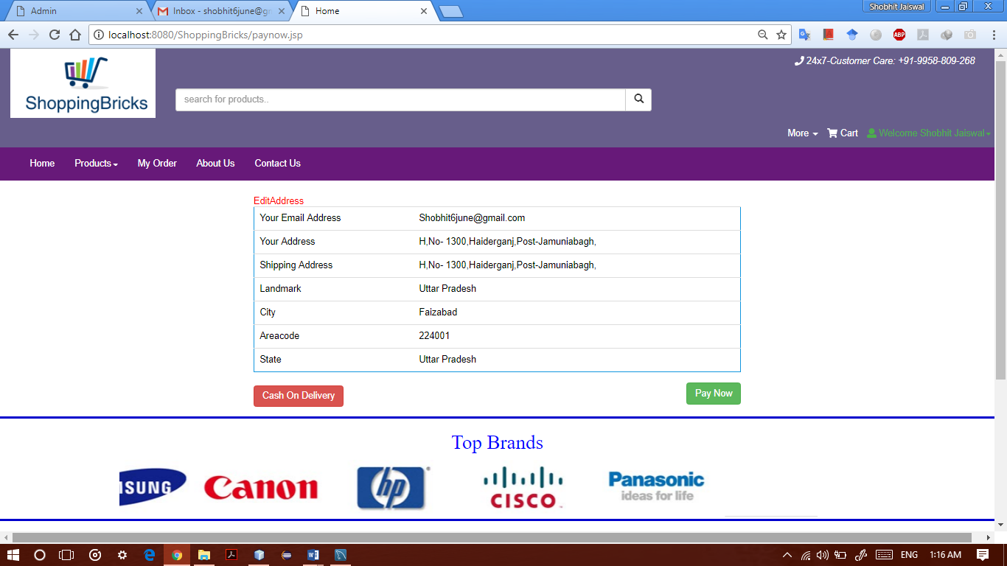

**9. Product info page**

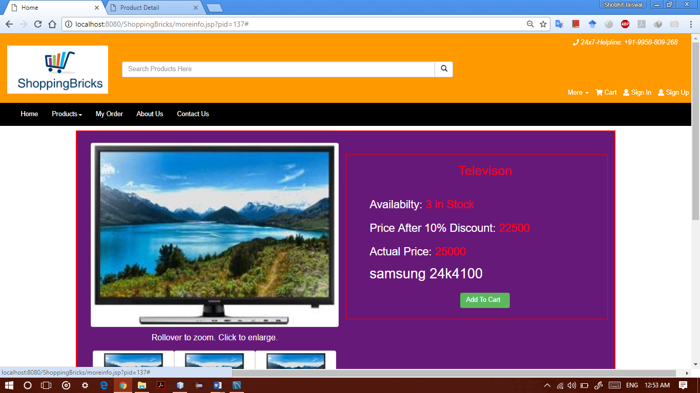

**10. Admin Login page**

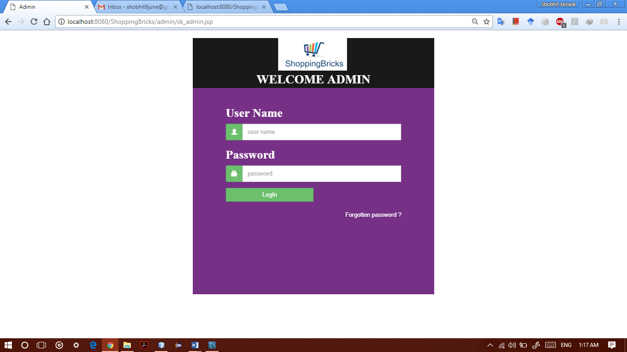

**11. Admin Dashboard page**

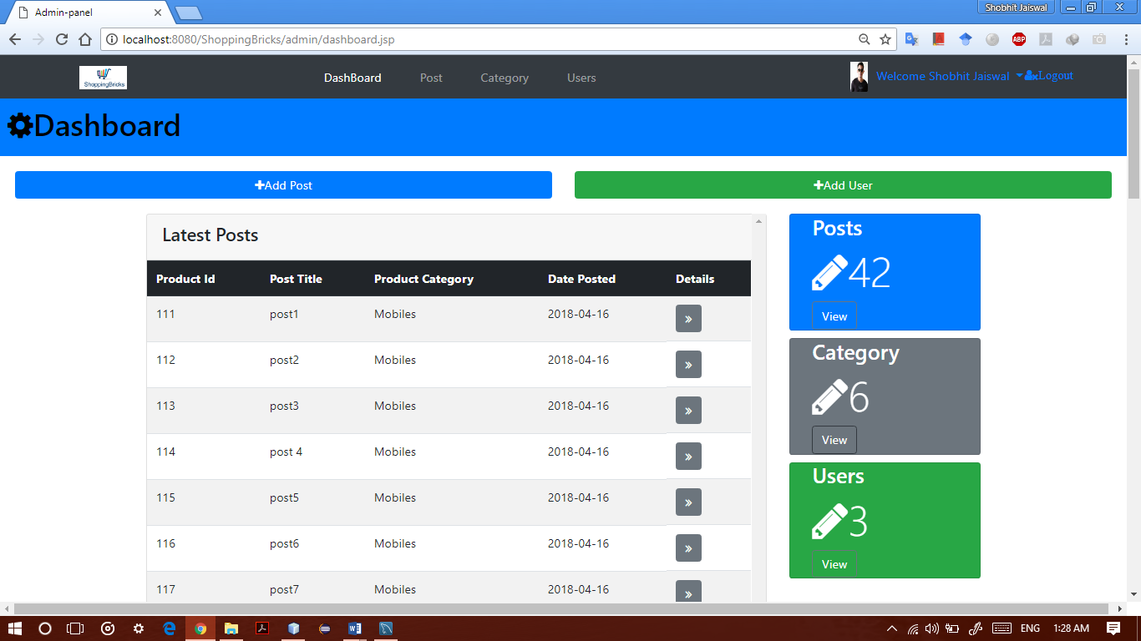

**12. Admin Add Post page**

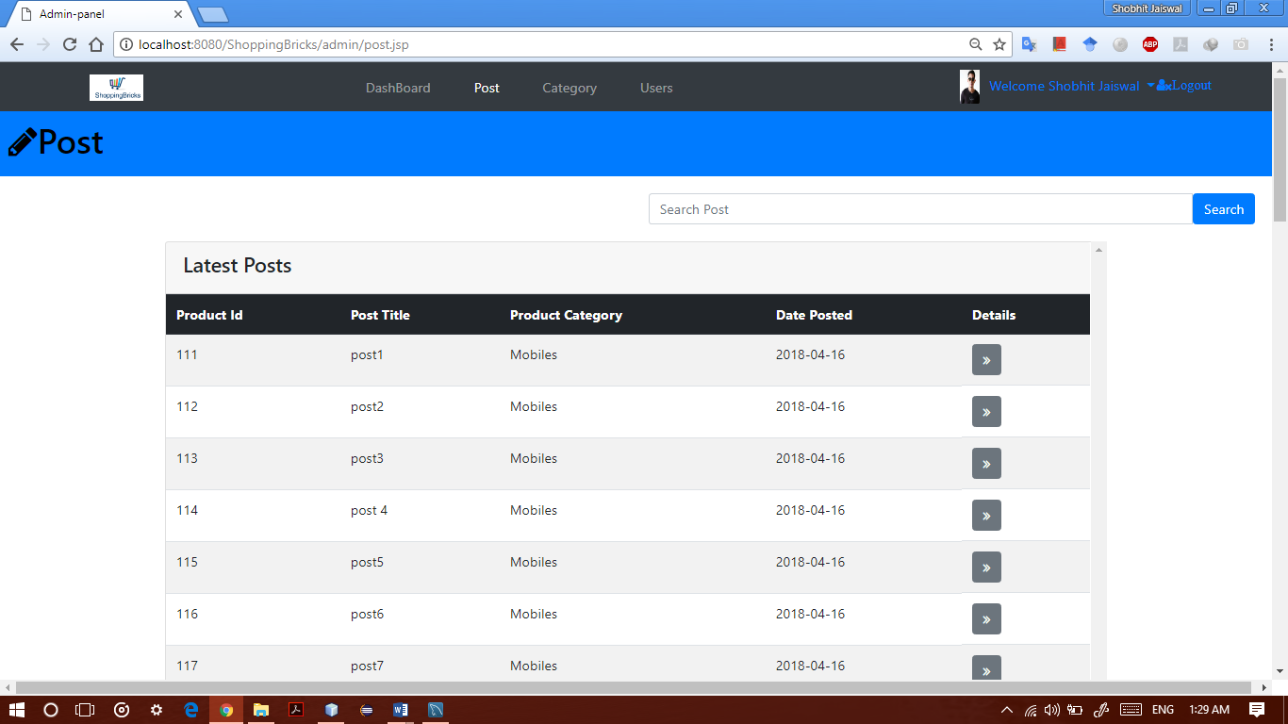

**13. Admin Category upload page**

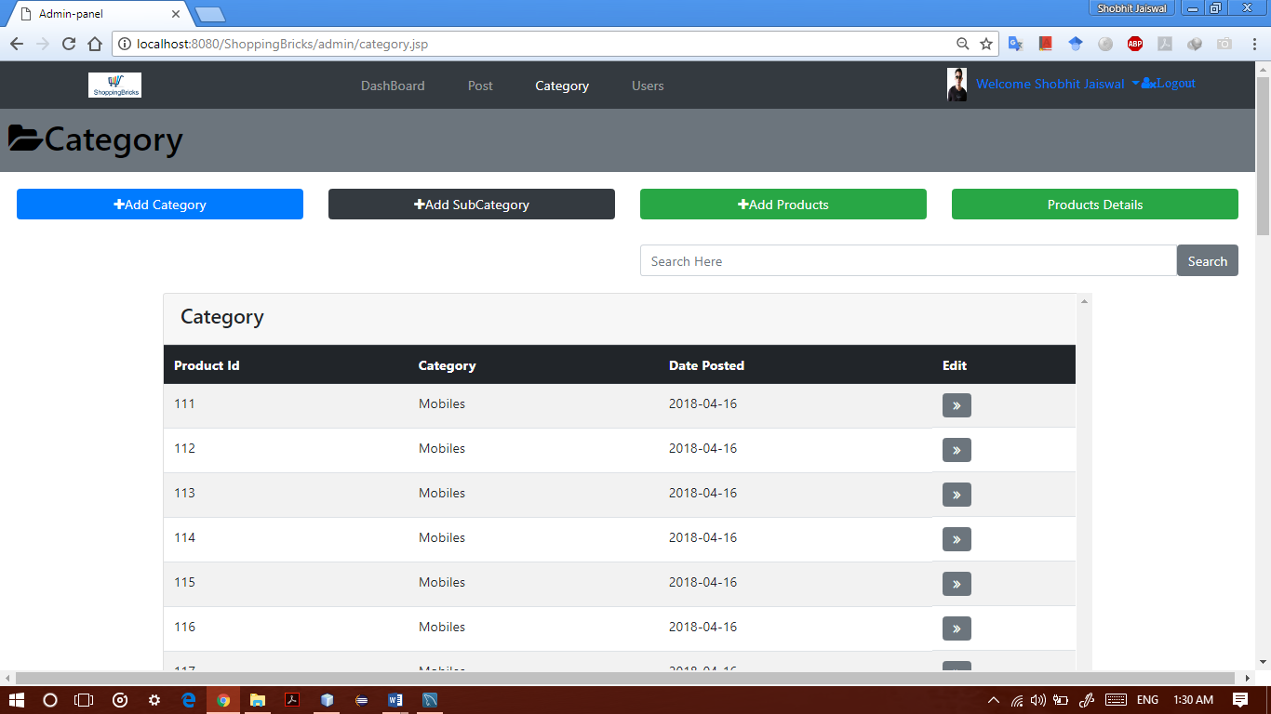

**14. Admin Add Users page**



**15. Admin Add Category page**

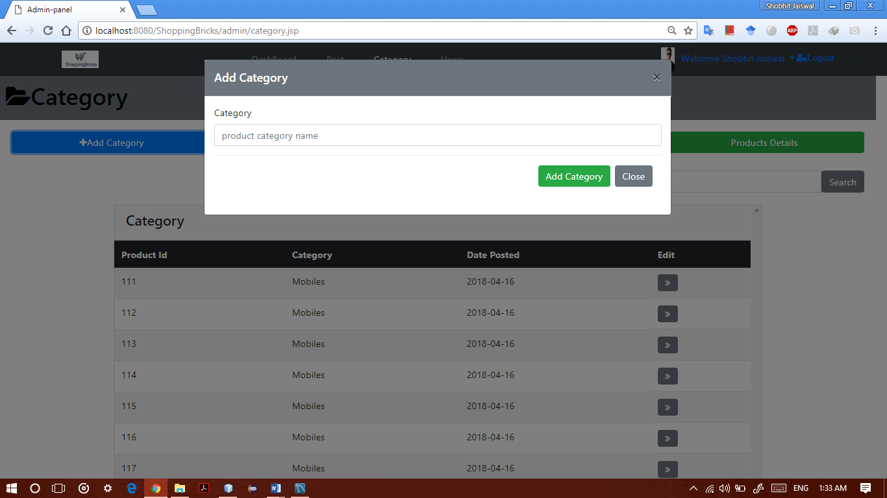

**16. Admin Add Sub Category page**

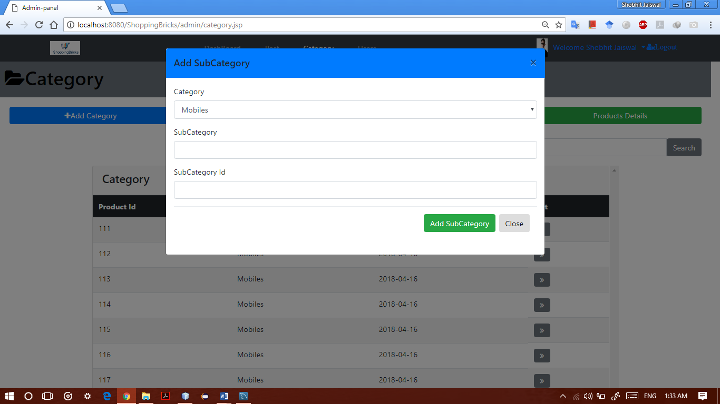

**17. Admin Add Products page**

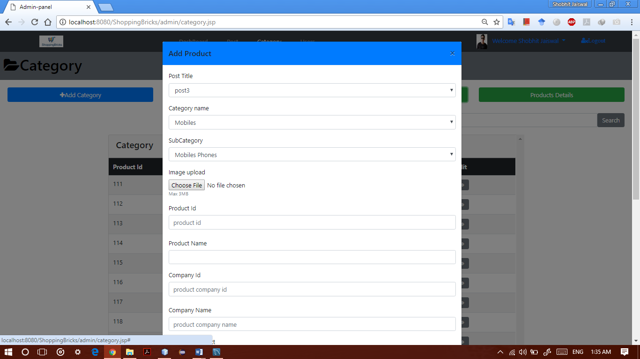

**18. Admin View All Products page**

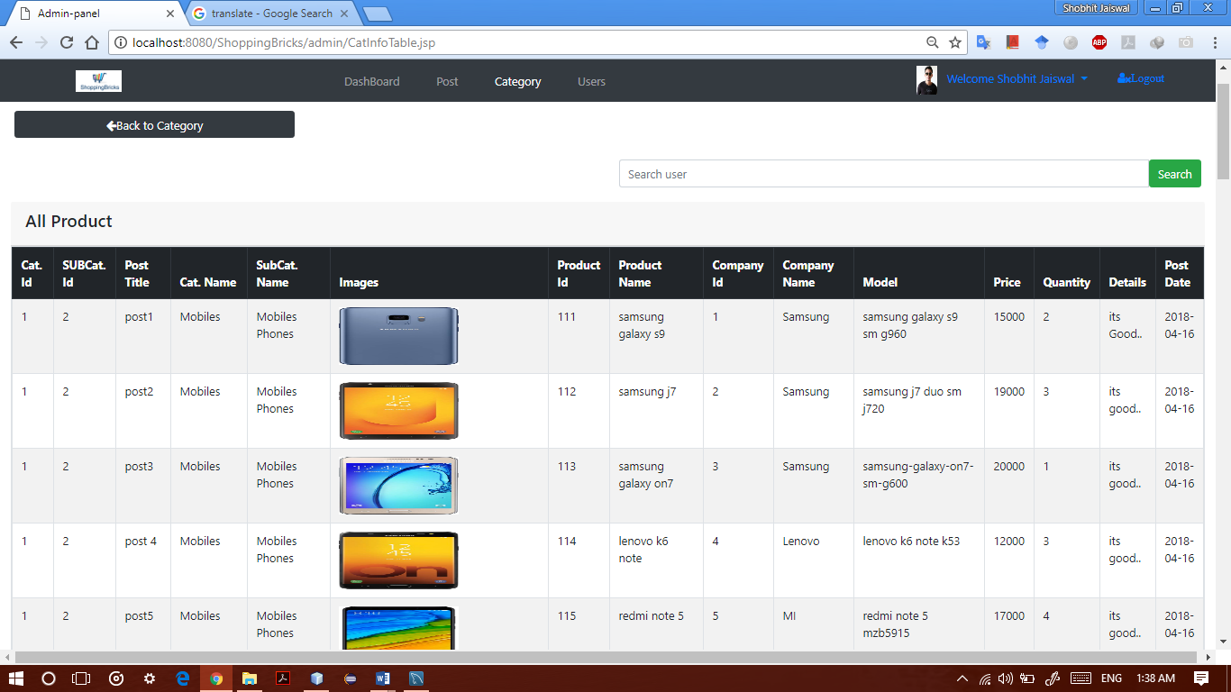

**19. Admin Product Info Table**

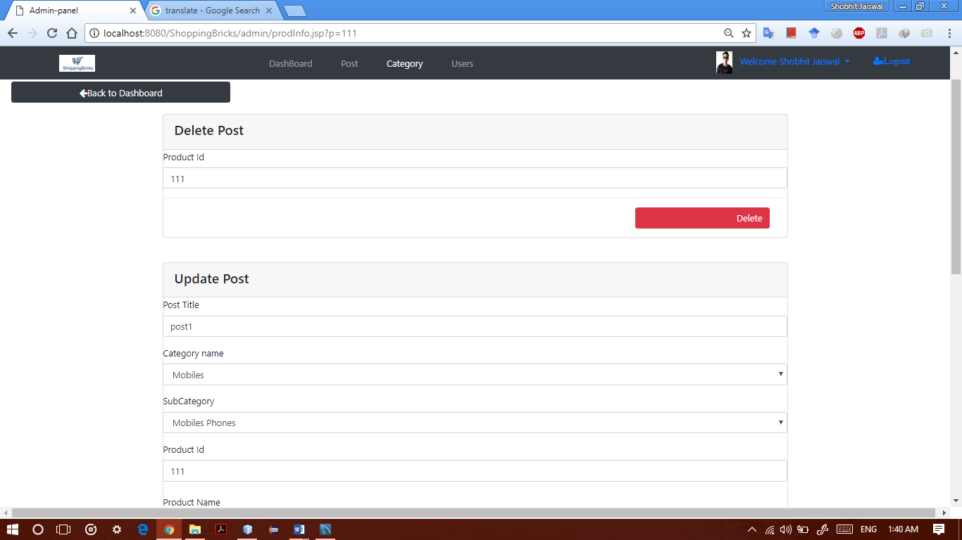

**20. Website Forgot Password page**

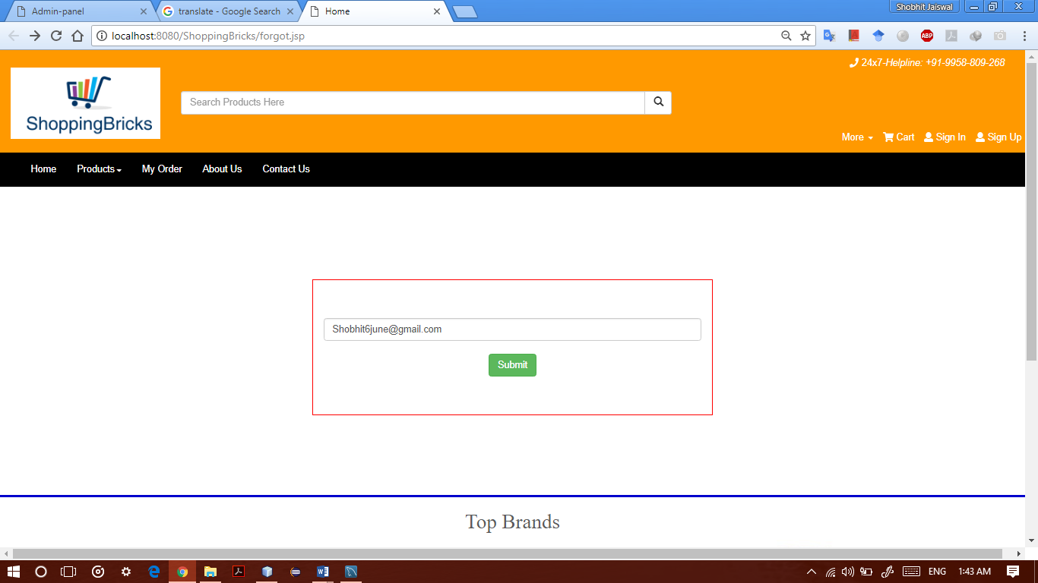

**5.3 Coding**

**1. Home Page**

<%--

Document : index

Created on : 22 Mar, 2018, 2:23:58 PM

Author : Shobhit Jaiswal

--%>

<%@page contentType="text/html" pageEncoding="UTF-8"%>

<!DOCTYPE html>

<%@page import="com.oreilly.servlet.MultipartRequest"%>

<%@page import="java.text.SimpleDateFormat"%>

<%@page import="java.sql.ResultSet"%>

<%@page import="java.sql.PreparedStatement"%>

<%@page import="java.sql.Connection"%>

<%@page import="connect.ConnectionProvider"%>

<%!

Connection connection=ConnectionProvider.getCon();

%>

<html>

<head>

<meta http-equiv="Content-Type" content="text/html; charset=UTF-8">

<title>Home :: ShoppingBricks</title>

<link href="bootstrap/css/bootstrap.css" rel="stylesheet" />

<link href="bootstrap/css/bootstrap.min.css" rel="stylesheet"/>

<link href="bootstrap/style.css" rel="stylesheet"/>

<link href="bootstrap/icon/css/fontawesome-all.css" rel="stylesheet"/>

<link href="bootstrap/icon/css/fontawesome-all.min.css" rel="stylesheet"/>

<link href="bootstrap/css/carousel.css" rel="stylesheet" type="text/css"/>

<script src="bootstrap/js/bootstrap.min.js" type="text/javascript"></script>

<scriptsrc="bootstrap/js/ie-emulation-modes-warning.js" type="text/javascript"></script>

<script src="bootstrap/js/jquery.min.js" type="text/javascript"></script>

<script defer src="https://use.fontawesome.com/releases/v5.0.6/js/all.js"></script>

</head>

<body>

<%

String msg1=request.getParameter("log1");

if(msg1!=null)

out.print("<script>alert('success registration')</script>");

%>

<%

String msg=request.getParameter("log");

if(msg!=null)

out.print("<script>alert('Invalid uname or pass..@Login Fail@')</script>");

%>

<%

String msg2=request.getParameter("log2");

if(msg2!=null)

out.print("<script>alert('@For View Cart Details Please SignIn If You Exist..Otherwise @Please SignUp ')</script>");

%>

<nav class="navbar navbar-default">

<!--header coding--->

<jsp:include page="header.jsp"></jsp:include>

<!--header coding--->

<div class="container-fluid" style="padding:0px 0px 0px 0px">

<div id="myCarousel" class="carousel slide" data-ride="carousel" style="height:300px">

<!-- Indicators -->

<ul class="carousel-indicators" >

<li data-target="#myCarousel" data-slide-to="0" class="active" ></li>

<li data-target="#myCarousel" data-slide-to="1"></li>

<li data-target="#myCarousel" data-slide-to="2"></li>

<li data-target="#myCarousel" data-slide-to="3"></li>

<li data-target="#myCarousel" data-slide-to="4"></li>

<li data-target="#myCarousel" data-slide-to="5"></li>

</ul>

<!-- Wrapper for slides -->

<div class="carousel-inner " style="height:300px">

<div class="item active img-responsive">

<img class=" img-responsive " src="images/Imgs/ba1.jpg" style="width:100%;height:300px">

</div>

<div class="item img-responsive">

<img class=" img-responsive " src="images/s0.jpeg" style="width:100%;height:300px">

</div>

<div class="item img-responsive">

<img class=" img-responsive " src="images/Imgs/ba2.jpg" style="width:100%;height:300px">

</div>

<div class="item img-responsive">

<img class=" img-responsive " src="images/s2.jpg" style="width:100%;height:300px">

</div>

<div class="item img-responsive">

<img class=" img-responsive " src="images/s3.jpg" style="width:100%;height:300px">

</div>

<div class="item img-responsive">

<img class=" img-responsive " src="images/Imgs/ba3.jpg" style="width:100%;height:300px">

</div>

<div class="item img-responsive">

<img class=" img-responsive " src="images/s4.jpg" style="width:100%;height:300px"/>

</div>

</div>

<!-- Left and right controls -->

<a class="left carousel-control" href="#myCarousel" data-slide="prev" >

<span class="glyphicon glyphicon-chevron-left" style="background-color:#000000"></span>

<span class="sr-only">Previous</span>

</a>

<a class="right carousel-control" href="#myCarousel" data-slide="next">

<span class="glyphicon glyphicon-chevron-right" style="background-color:#000000"></span>

<span class="sr-only">Next</span>

</a>

</div>

</div>

<!------------------------slider end-------------------->

<!--------start banner-bottom table list menu------>

<div class="container-fluid" style="border: 2px solid #671979;border-top:2px solid #671979; background-color: #ffffff;margin-top:-50px;">

<div class="container-fluid" >

<div class="row jumbotron" style="background-color: #ffffff" >

<div role="tabpanel" data-example-id="togglable-tabs">

<ul id="myTab" class="nav nav-tabs " role="tablist">

<%

PreparedStatement ps=connection.prepareStatement("select pcat_id,pcname from prod_cat");

ResultSet rs=ps.executeQuery();

int a=0;

while (rs.next())

{

// k++;

a=rs.getInt("pcat_id");

System.out.println("id:"+a);

if(a==1)

{

%>

<li role="presentation" class="active"><a href="#<%=a%>" id="home-tab" role="tab" data-toggle="tab" aria-controls="home"><%=rs.getString("pcname")%></a></li>

<% }else

{

%>

<li role="presentation" ><a href="#<%=a%>" id="home-tab" role="tab" data-toggle="tab" aria-controls="home"><%=rs.getString("pcname")%></a></li>

<% } %>

</ul>

<div id="myTabContent" class="tab-content">

<div role="tabpanel" class="tab-pane fade active in" id="1" aria-labelledby="home-tab">

<div style="margin-top: 20px">

<%

// String s=request.getParameter("var");

// out.println("s:"+s);

PreparedStatement ps1=connection.prepareStatement("select * from product where pcat_id=? ");

ps1.setInt(1,1);

ResultSet rs1=ps1.executeQuery();

while (rs1.next()) {

%>

<div class="col-lg-3 col-md-4 col-sm-6 text-center " style="margin-top: 50px;">

<ahref="moreinfo.jsp?pid=<%=rs1.getInt("pid")%>"><img src="<%=rs1.getString("pimageurl")%>" alt=" " style="width: 130px;height:250px"/></a>

<h5><ahref="moreinfo.jsp?pid=<%=rs1.getInt("pid")%>"><%=rs1.getString("pmodel")%></a><br>Rs.<%=rs1.getInt("price")%></h5>

<a href="AddCart?pid=<%=rs1.getInt("pid")%>"> <button class="btn btn-danger" style="margin-top:10px;" >&nbsp Add To Cart </button> </a>

</div>

<%

}

%>

<div class="clearfix"> </div>

</div>

<div role="tabpanel" class="tab-pane fade" id="2" aria-labelledby="video-tab" >

<div class="text-center" style="margin-top: 20px">

<%

// String s=request.getParameter("var");

// out.println("s:"+s);

PreparedStatement ps2=connection.prepareStatement("select * from product where pcat_id=? ");

ps2.setInt(1,2);

ResultSet rs2=ps2.executeQuery();

while (rs2.next()) {

%>

<div class="col-lg-3 col-md-4 col-sm-6 text-center " style="margin-top: 50px;">

<ahref="moreinfo.jsp?pid=<%=rs2.getInt("pid")%>"> <img src="<%=rs2.getString("pimageurl")%>" alt=" " style="width: 180px;height:150px"/></a>

<h5><ahref="moreinfo.jsp?pid=<%=rs2.getInt("pid")%>"><%=rs2.getString("pmodel")%></a><br>Rs.<%=rs2.getInt("price")%></h5>

<a href="AddCart?pid=<%=rs2.getInt("pid")%>"> <button class="btn btn-danger" style="margin-top:10px;">&nbsp Add To Cart </button> </a>

</div>

<%

}

%>

<div class="clearfix"> </div>

</div>

<div role="tabpanel" class="tab-pane fade" id="3" aria-labelledby="audio-tab">

<div style="margin-top: 20px">

<%

// String s=request.getParameter("var");

// out.println("s:"+s);

PreparedStatement ps3=connection.prepareStatement("select * from product where pcat_id=? ");

ps3.setInt(1,3);

ResultSet rs3=ps3.executeQuery();

while (rs3.next()) {

%>

<div class="col-lg-3 col-md-4 col-sm-6 text-center" style="margin-top: 50px;">

<a href="moreinfo.jsp?pid=<%=rs3.getInt("pid")%>"><img class="text-center" src="<%=rs3.getString("pimageurl")%>" alt=" " style="width: 190px;height:150px"/></a>

<h5><ahref="moreinfo.jsp?pid=<%=rs3.getInt("pid")%>"><%=rs3.getString("pmodel")%></a><br>Rs.<%=rs3.getInt("price")%></h5>

<a href="AddCart?pid=<%=rs3.getInt("pid")%>"> <button class="btn btn-danger" style="margin-top:10px;">&nbsp Add To Cart </button> </a>

</div>

<%

}

%>

<div class="clearfix"> </div>

<div style="margin-top: 20px">

<%

// String s=request.getParameter("var");

// out.println("s:"+s);

PreparedStatement ps4=connection.prepareStatement("select * from product where pcat_id=? ");

ps4.setInt(1,4);

ResultSet rs4=ps4.executeQuery();

while (rs4.next()) {

%>

<div class="col-lg-3 col-md-4 col-sm-6 text-center" style="margin-top: 50px;">

<a href="moreinfo.jsp?pid=<%=rs4.getInt("pid")%>"><img class="text-center" src="<%=rs4.getString("pimageurl")%>" alt=" " style="width: 180px;height:150px"/></a>

<h5><ahref="moreinfo.jsp?pid=<%=rs4.getInt("pid")%>"><%=rs4.getString("pmodel")%></a><br>Rs.<%=rs4.getInt("price")%></h>

<a href="AddCart?pid=<%=rs4.getInt("pid")%>"> <button class="btn btn-danger" style="margin-top:10px;">&nbsp Add To Cart </button> </a>

<%

}

%><div class="clearfix"> </div></div>

</div><div role="tabpanel" class="tab-pane fade" id="5" aria-labelledby="kitchen-tab">

<div style="margin-top: 20px">

<%

// String s=request.getParameter("var");

// out.println("s:"+s);

PreparedStatement ps5=connection.prepareStatement("select * from product where pcat_id=? ");

ps5.setInt(1,5);

ResultSet rs5=ps5.executeQuery();

while (rs5.next()) {

%>

<div class="col-lg-3 col-md-4 col-sm-6 text-center" style="margin-top: 50px;">

<a href="moreinfo.jsp?pid=<%=rs5.getInt("pid")%>"><img class="text-center" src="<%=rs5.getString("pimageurl")%>" alt=" " style="width: 180px;height:180px"/></a>

<h5><ahref="moreinfo.jsp?pid=<%=rs5.getInt("pid")%>"><%=rs5.getString("pmodel")%></a><br>Rs.<%=rs5.getInt("price")%></h5>

<a href="AddCart?pid=<%=rs5.getInt("pid")%>"> <button class="btn btn-danger" style="margin-top:10px;">&nbsp Add To Cart </button> </a>

</div>

<%

}

%>

<div class="clearfix"> </div>

</div>

</div> </div>

<-- //banner-bottom --></nav>

<!----------------------------------- END OF HEADER CODING-------------------------------------------------------------------------------->

<!----------------------------------- Footer coding----------------------------->

<jsp:include page="footer.jsp"></jsp:include>

<!----------------------------------- end of Footer coding------------------------------------------>

</body>

</html>

**2. Header page**

<%--

Document : header

Created on : 22 Mar, 2018, 2:17:42 PM

Author : Shobhit Jaiswal

--%>

<%@page contentType="text/html" pageEncoding="UTF-8"%>

<!DOCTYPE html>

<%@page import="com.oreilly.servlet.MultipartRequest"%>

<%@page import="java.text.SimpleDateFormat"%>

<%@page import="java.sql.ResultSet"%>

<%@page import="java.sql.PreparedStatement"%>

<%@page import="java.sql.Connection"%>

<%@page import="connect.ConnectionProvider"%>

<html>

<head>

<meta http-equiv="Content-Type" content="text/html; charset=UTF-8">

<title>header Page</title>

<link href="bootstrap/css/bootstrap.css" rel="stylesheet" />

<link href="bootstrap/css/bootstrap.min.css" rel="stylesheet"/>

<link href="bootstrap/style.css" rel="stylesheet"/>

<link href="bootstrap/icon/css/fontawesome-all.css" rel="stylesheet"/>

<link href="bootstrap/icon/css/fontawesome-all.min.css" rel="stylesheet"/>

<link href="bootstrap/css/carousel.css" rel="stylesheet" type="text/css"/>

<script src="bootstrap/js/bootstrap.js" type="text/javascript"></script>

<script src="bootstrap/js/ie-emulation-modes-warning.js" type="text/javascript"></script>

<script src="https://ajax.googleapis.com/ajax/libs/jquery/3.3.1/jquery.min.js"></script>

<script src="https://maxcdn.bootstrapcdn.com/bootstrap/3.3.7/js/bootstrap.min.js"></script>

<script defer src="https://use.fontawesome.com/releases/v5.0.6/js/all.js"></script>

</head>

<body>

<%!

String label=null;

Connection connection=ConnectionProvider.getCon();

%>

<div id="home1" class="container-fluid" style="background-color:#ff9900">

<div class="row">

<div class="col-md-2 text-center logo" style="margin-top: 25px">

<a href="index.jsp"><img src="images/Capture.PNG"/></a> </div>

<div class="col-md-6" style="margin-top:60px; border: 2px">

<form action="search_result.jsp">

<div class="input-group">

<input type="text" name="query" class="form-control" placeholder="Search Products Here" />

<div class="input-group-btn">

<button class="btn btn-default" type="submit" style="height:34px">

<i class="glyphicon glyphicon-search"></i>

</button> </div>

</div>

</form>

</div>

<div class="col-md-4 text-right">

<div class="row" style="margin:10px">

<ul class="list-inline menu">

<li><a href="#"><i class=" fa fa-phone"> </i> 24x7<i>-Helpline: +91-9958-809-268</i></a></li>

</ul>

</div>

<!------------ more and add cart sign in & sign out------->

<div class="row" style="margin-top: 80px">

<ul class="list-inline menu"><li class="dropdown more_list"><a class="dropdown-toggle" data-toggle="dropdown" href="#">More <span class="caret"></span></a>

<ul class="dropdown-menu">

<li><a href="#"><i class="fa fa-user"> </i> Sell </a></li> <li role="presentation" class="divider"></li>

<li><a href="#"><i class=" fa fa-gift"> </i> Today's Deal </a></li> <li role="presentation" class="divider"></li>

<li><a href="#"><i class=" fa fa-phone"> </i> 24x7 Customer Care</a></li>

<li role="presentation" class="divider"></li>

<li><a href="#"><i class=" fa fa-map-marker"> </i> Track Order</a></li>

</ul> </li>

<li><a href="validate.jsp" class="active"><i class="fa fa-shopping-cart"></i> Cart</a></li>

<%

label=(String)session.getAttribute("user2");

if(label==null)

{

%>

<li data-toggle="modal" data-target="#login"><a href="#"><i class="fas fa-user"></i><span > Sign In</span></a></li> <li data-toggle="modal" data-target="#signup"><a href="#"><i class="fas fa-user"></i><span> Sign Up</span></a></li>

<%

}else

{

%> <li class="dropdown more_list"><a style=" color:#4cae4c" class="dropdown-toggle" data-toggle="dropdown" href="#"><i class="fas fa-user"></i> Welcome <%=label%><span class="caret"></span></a>

<ul class="dropdown-menu">

<li><a href="#"><i class="fa fa-user"> </i> Your Profile </a></li>

<li role="presentation" class="divider"></li>

<li><a href="#"><i class=" fa fa-gift"> </i> Change Password </a></li>

<li role="presentation" class="divider"></li>

<li><a href="#"><i class=" fa fa-phone"> </i> Your Order</a></li>

</ul></li> <li ><a style="color: red" href="logout.jsp"><i class="fas fa-user"></i><span> Logout</span></a></li>

<%

}

%> </ul>

<div class="row" >

<div class="col-lg-12">

<!-- Modal -->

<div id="login" class="modal fade" role="dialog">

<div class="modal-dialog">

<!-- Modal content-->

<div class="modal-content">

<div class="modal-header">

<button type="button" class="close" data-dismiss="modal">&times;</button>

<h4 class="modal-title"></h4>

</div>

<div class="modal-body">

<div class="panel panel-primary">

<div class="panel-heading text-left">

Welcome to SIGN IN

</div>

<div class="panel-body">

<form action="jspFile/login.jsp" method="post">

<div class="form-group">

<input type="text" name="uname" placeholder="Your user name" required="" class="form-control" />

</div>

<div class="form-group">

<input type="password" name="upass" placeholder="Your Password" required="" class="form-control" />

</div>

<div class="form-group text-left">

<input type="submit" value="SIGN IN" class="btn btn-success" />

</div>

<div class="form-group text-right">

<ul style="list-style: none">

<li><a href="forgot.jsp">Forgotten Password ?</a></li>

</ul>

</div>

</form></div>

</div>

<center><h4>OR</h4></center>

</div>

<div class="modal-footer text-center"> <span class="follow">

<center>

<a href="https://www.facebook.com/" target="_blank"><i class="fab fa-facebook-square"></i></a>

<a href="https://www.twitter.com/" target="_blank"><i class="fab fa-twitter"></i></a>

<a href="https://plus.google.com/" target="_blank"><i class="fab fa-google-plus"></i></a>

</center> </span>

</div></div>

</div></div>

</div></div>

<div class="row" >

<div class="col-lg-12">

<!-- Modal -->

<div id="signup" class="modal fade" role="dialog">

<div class="modal-dialog">

<!-- Modal content-->

<div class="modal-content">

<div class="modal-header">

<button type="button" class="close" data-dismiss="modal">&times;</button>

<!--- <h4 class="modal-title"></h4>--->

</div>

<div class="modal-body">

<div class="panel panel-primary">

<div class="panel-heading text-left">

Welcome to CREATE ACCOUNT !!

</div>

<div class="panel-body">

<form action="jspFile/register.jsp" method="post">

<div class="form-group">

<input type="text" name="uid" placeholder="Your User Id" required="" class="form-control" />

</div>

<div class="form-group">

<input type="text" name="uname" placeholder="Your Name" required="" class="form-control" />

</div>

<div class="form-group">

<input type="password" name="upass" placeholder="your Password" required="" class="form-control" />

</div>

<div class="form-group">

<input type="password" name="ucpass" placeholder="confirm Password" required="" class="form-control" />

</div>

<div class="form-group">

<input type="email" name="uemail" placeholder="Your Email" required="" class="form-control" />

</div>

<div class="form-group">

<input type="text" name="uphone" placeholder="Phone Number" required="" class="form-control" />

</div>

<div class="form-group text-left">

<input type="submit" value="CREATE ACCOUNT" class="btn btn-success" />

<input type="reset" value="RESET" class="btn btn-primary" />

</div>

</form></div>

</div></div>

</div></div>

</div>

</div>

<!------------ more and add cart sign in & sign out------->

</div>

<!--------------------start of menu bar-------------->

<div class="container-fluid" style="background-color:black">

<div class="navbar-header" >

<button type="button" class="navbar-toggle collapsed" data-toggle="collapse" data-target="#navbar" aria-expanded="false" aria-controls="navbar">

</button>

</div>

<div id="navbar" class="navbar-collapse collapse">

<ul class="nav navbar-nav home_menu">

<li><a href="index.jsp" class="hm">Home</a></li>

<li class="dropdown">

<a href="#" class="dropdown-toggle hm" data-toggle="dropdown" role="button" aria-haspopup="true" aria-expanded="false" style="background-color:black">Products<span class="caret"></span></a>

<ul class="dropdown-menu multi-column-dropdown columns-3">

<div class="row">

<%

PreparedStatement ps=connection.prepareStatement("select pcat_id,pcname from prod_cat");

ResultSet rs=ps.executeQuery();

while (rs.next())

{ int s=rs.getInt("pcat_id");

PreparedStatement ps1=connection.prepareStatement("select * from p_subcat where pcat_id=? ");

ps1.setInt(1, s);

ResultSet rs1=ps1.executeQuery();

%>

<div class="col-lg-2">

<ul class="multi-column-dropdown">

<h6><%=rs.getString("pcname")%></h6>

<%

while (rs1.next())

{

%>

<li><ahref="products.jsp?p=<%=rs1.getInt("psubcat_id")%>"><%=rs1.getString("psubcatname")%></a></li>

<% } %>

</ul> <% } %>

<div class="clearfix"></div>

</div>

</ul>

</li>

<li><a href="validate.jsp" class="hm">My Order</a></li>

<li><a href="aboutus.jsp" class="hm">About Us</a></li>

<li><a href="contact.jsp" class="hm">Contact Us</a></li>

</li>

</ul>

</div><!--/.nav-collapse -->

</div><!--/.container-fluid -->

<!--------------------end of menu bar-------------->

</body>

</html>

**3. Products page**

<%--

Document : products

Created on : 8 Apr, 2018, 1:37:29 AM

Author : Shobhit Jaiswal

--%>

<%@page import="com.oreilly.servlet.MultipartRequest"%>

<%@page import="java.text.SimpleDateFormat"%>

<%@page import="java.sql.ResultSet"%>

<%@page import="java.sql.PreparedStatement"%>

<%@page import="java.sql.Connection"%>

<%@page import="connect.ConnectionProvider"%>

<%!

Connection conne=ConnectionProvider.getCon();

%>

<%@page contentType="text/html" pageEncoding="UTF-8"%>

<!DOCTYPE html>

<html>

<head>

<meta http-equiv="Content-Type" content="text/html; charset=UTF-8">

<title>JSP Page</title>

<link href="bootstrap/css/bootstrap.css" rel="stylesheet" />

<link href="bootstrap/css/bootstrap.min.css" rel="stylesheet"/>

<link href="bootstrap/style.css" rel="stylesheet"/>

<link href="bootstrap/icon/css/fontawesome-all.css" rel="stylesheet"/>

<link href="bootstrap/icon/css/fontawesome-all.min.css" rel="stylesheet"/>

<link href="bootstrap/css/carousel.css" rel="stylesheet" type="text/css"/>

<script src="bootstrap/js/bootstrap.min.js" type="text/javascript"></script>

<script src="bootstrap/js/ie-emulation-modes-warning.js" type="text/javascript"></script>

<script src="bootstrap/js/jquery.min.js" type="text/javascript"></script>

<script defer src="https://use.fontawesome.com/releases/v5.0.6/js/all.js"></script>

</head>

<body>

<%@include file="header.jsp"%>

<div class="jumbotron" style="border:1px solid #0000CC;background-color: #ffffff>

<div style="margin-top: -45px">

<%

// String s=request.getParameter("var");

// out.println("s:"+s);

int var=Integer.parseInt(request.getParameter("p"));

PreparedStatement ps13=conne.prepareStatement("select * from product where psubcat_id=?");

ps13.setInt(1,var);

ResultSet rs13=ps13.executeQuery();

PreparedStatement ps14=conne.prepareStatement("select * from p_subcat where psubcat_id=?");

ps14.setInt(1,var);

ResultSet rs14=ps14.executeQuery();

while (rs13.next()) {

if(rs14.next())

{

%>

<spanclass="input-group-addon"><center><h2 style="color:red"><%=rs13.getString("psubcatname")%></h2></center></span>

<%

}

%>

<div class="col-lg-3 col-md-4 col-sm-6 text-center " style="margin-top: 50px;">

<ahref="moreinfo.jsp?pid=<%=rs13.getInt("pid")%>"><img src="<%=rs13.getString("pimageurl")%>" alt=" " style="width: 150px;height:250px"/></a>

<h5><ahref="moreinfo.jsp?pid=<%=rs13.getInt("pid")%>"><%=rs13.getString("pname")%></a><br>Rs.<%=rs13.getInt("price")%></h5>

<a href="AddCart?pid=<%=rs13.getInt("pid")%>"> <button class="btn btn-danger" style="margin-top:10px;">&nbsp Add To Cart </button> </a>

</div> <% } %>

<div class="clearfix"> </div>

</div><div class="footer-copy1" style="padding-left:100px">

<nav class="pages"><ul class="pagination">

<li class="page-item disabled"><a href="#" class="page-link">Previous</a></li>

<li class="page-item active"><a href="postpage1" class="page-link">1</a></li>

<li class="page-item"><a href="postpage2" class="page-link">2</a></li>

<li class="page-item"><a href="postpage3" class="page-link">3</a></li>

<li class="page-item"><a href="postpage4" class="page-link">Next</a></li></ul> </nav>

</div></div></div>

<%@include file="footer.jsp"%>

</body>

</html>

**4. Check Cart page**

<div class="container signup" >

<div class="row">

<div class="col-lg-3"></div><div class="col-lg-6">

<form action="paynow.jsp" method="post">

<div class="panel panel-primary">

<div class="panel-heading">

<div class="panel-title"> User Details:- </div>

</div>

<div class="form-group">

<div class="input-group">

<span class="input-group-addon"><i class="fa fa-user text-primary"></i></span>

<input type="email" name="email" class="form-control" placeholder="Please Enter Your Email" required /> </div> </div>

<div class="form-group">

<div class="input-group">

<span class="input-group-addon"><i class="fa fa-user text-primary"></i></span>

<input type="text" name="address" class="form-control" placeholder="Please Enter Permanent Address" required />

</div></div>

<div class="form-group">

<div class="input-group">

<span class="input-group-addon"><i class="fa fa-user text-primary"></i></span>

<input type="text" name="ship_address" class="form-control" placeholder="Please Enter Shipping Address" required />

</div></div><div class="form-group">

<div class="input-group">

<span class="input-group-addon"><i class="fa fa fa-map text-primary"></i></span>

<input type="text" name="city" class="form-control" placeholder="Please Enter Your City" required />

</div></div>

<div class="form-group">

<div class="input-group">

<span class="input-group-addon"><i class="fa fa-map text-primary"></i></span>

<input type="text" name="landmark" class="form-control" placeholder="Please Enter LandMark" required /></div>

</div>

<div class="form-group">

<div class="input-group">

<span class="input-group-addon"><i class="fa fa-map text-primary"></i></span>

<input type="text" name="areacode" class="form-control" placeholder="Please Enter Area Code" required /></div>

</div><div class="form-group">

<div class="input-group">

<span class="input-group-addon"><i class="fa fa-map text-primary"></i></span>

<input type="text" name="state" class="form-control" placeholder="Please Enter State" required /> </div>

</div>

<div class="panel-footer">

<input type="reset" class="btn btn-primary" value="Reset"/>

<input type="submit" class="btn btn-primary pull-right" value="Submit"/>

</div>

</div></form>

</div></div></div>

**5. View Cart page**

<!doctype html>

<head>

<title>Home</title>

<meta http-equiv="Content-Type" content="text/html; charset=windows-1252" />

<link href="bootstrap/css/bootstrap.css" rel="stylesheet" />

<link href="bootstrap/css/bootstrap.min.css" rel="stylesheet"/>

<link href="bootstrap/style.css" rel="stylesheet"/>

<link href="bootstrap/icon/css/fontawesome-all.css" rel="stylesheet"/>

<link href="bootstrap/icon/css/fontawesome-all.min.css" rel="stylesheet"/>

<link href="bootstrap/css/carousel.css" rel="stylesheet" type="text/css"/>

<script src="bootstrap/js/bootstrap.min.js" type="text/javascript"></script>

<script src="bootstrap/js/ie-emulation-modes-warning.js" type="text/javascript"></script>

<script src="bootstrap/js/jquery.min.js" type="text/javascript"></script>

<script defer src="https://use.fontawesome.com/releases/v5.0.6/js/all.js"></script>

</head>

<body>

<%@include file="header2.jsp"%>

<%@page import="java.util.ArrayList"%>

<%@page import="java.sql.Connection"%>

<%@page import="connect.ConnectionProvider"%>

<%@page import="java.sql.Statement"%>

<%@page import="java.sql.ResultSet"%>

<%!

//out.print("connection::::"+connection); %>

<br/>

<div class="container">

<div class="row" >

<div class="col-lg-9">

<div class="table-responsive" style="color:black;">

<table class=" table table-bordered table-hover">

<tr style="color:#525252; background-color:#C9C9C9; font-family:Roboto; font-style:inherit; font-variant:normal; font-size:18px;">

<td class="text-center">Product</td>

<td class="text-center" style="width:400px;">Discription</td>

<td class="text-center" style="width:50px;">Product Model</td>

<td class="text-center"style="width:50px; ">Price</td>

<td class="text-center" >Quantity</td>

<td class="text-center" ></td>

<%

ArrayList itemlist = (ArrayList) session.getAttribute("cartID");

Connection connection=ConnectionProvider.getCon();

Statement stmt=connection.createStatement();

int price=0;

if(itemlist == null)

{

out.println("<h1>Have No cart!</h1>");

}

else{

int a=0;

//Integer pid[]=new Integer[itemlist.size()];

for(int i=0 ; i< itemlist.size();i++)

{

//pid[i]=(Integer)itemlist.get(i);<%=itemlist.get(i)

rs=stmt.executeQuery("select * from product where pid="+itemlist.get(i));

while(rs.next())

{

a++;

//out.print(rs.getInt(1) +".."+rs.getString(5));

price=price+rs.getInt("price");

%></tr>

<tr style="font-size:16px; ">

<td><img src="<%=rs.getString("pimageurl")%>" alt="<%=rs.getString("pmodel")%>" height="92" width="80" ></td>

<td><%=rs.getString("pmodel")%></td>

<td class="text-center"><%=rs.getString("pmodel")%></td>

<td class="text-center"><%=rs.getInt("price")%></td>

<td class="text-right"><%=1%></td>

<td class="text-center" onclick="window.location.href='DeleteCart?pid=<%=rs.getInt("pid") %>';" style="cursor:pointer;"><i class="fa fa-trash"> </i></td>

</tr>

<% }}%>

<tr class="text-right">

<td colspan="4">

<h3 class="text-primary"> Amount Payable (<%=a%> Items Selected)</h3></td>

<td colspan="2"> <h3 class="text-primary "> Rs.&nbsp <%=price%> </h3>

</td></tr>

<tr><td colspan="6"> <button class="btn btn-danger pull-left" value="Submit" onClick="window.location.href='index.jsp';"> Continue Shopping</button>

<button class="btn btn-primary pull-right" value="Submit" onClick="window.location.href='checkOut.jsp';"> Process to Check</button></td></tr>

<% } %> </table></div> </div>

</div> </div>

</div> <%@include file="footer.jsp"%>

</body>

</html>

**6. Admin Login**

<%--

Document : login_admin.jsp

Created on : 22 Mar, 2018, 2:57:07 PM

Author : Shobhit Jaiswal

--%>

<%@page contentType="text/html" pageEncoding="UTF-8"%>

<!DOCTYPE html>

<html>

<head>

<meta http-equiv="Content-Type" content="text/html; charset=UTF-8">

<title> Admin Login</title>

<meta charset="UTF-8">

<meta name="viewport" content="width=device-width, initial-scale=1.0">

<link href="../bootstrap/css/bootstrap.css" rel="stylesheet" />

<link href="../bootstrap/css/bootstrap.min.css" rel="stylesheet"/>

<link href="../bootstrap/style.css" rel="stylesheet"/>

<link href="../bootstrap/icon/css/fontawesome-all.css" rel="stylesheet"/>

<link href="../bootstrap/icon/css/fontawesome-all.min.css" rel="stylesheet"/>

<link href="../bootstrap/css/carousel.css" rel="stylesheet" type="text/css"/>

<script src="../bootstrap/js/bootstrap.js" type="text/javascript"></script>

<script src="../bootstrap/js/ie-emulation-modes-warning.js" type="text/javascript"></script>

<script src="https://ajax.googleapis.com/ajax/libs/jquery/3.3.1/jquery.min.js"></script>

<script src="https://maxcdn.bootstrapcdn.com/bootstrap/3.3.7/js/bootstrap.min.js"></script>

<script defer src="https://use.fontawesome.com/releases/v5.0.6/js/all.js"></script>

<style>

body{

width: 100%;

height: 100px;

background-image: url('../images/ad.jpeg');

background-repeat: no-repeat;

background-size: cover;

}

.admin_logo{

width:30%;

}

.login-name{

font-size: 30px;

font-family: Arabic typeseting;

color:#FFFFFF;

}

.login_banner{

opacity: 0.90;

}

.login{

background-color: #0d0d0d;

min-height: 500px;

opacity: 0.90;

padding: 40px 80px 40px 80px;

}

.user{

font-size: 29px;

font-family: Arabic typeseting;

color: #FFFFFF;

}

.input-group-addon{

background-color: #5cb85c;

border-color: #4cae4c;

color: #fff;

}

.text1{ border-radius: 0px;

height: 40px;

}

.btn1{

border-radius: 0px;

float: left;

width: 50%;

}

</style>

</head>

<body>

<%

String msg2=request.getParameter("log2");

if(msg2!=null)

out.print("<script>alert('Login Failed...invalid uname or pass')</script>");

%><div class="container">

<div class="row">

<br><div class="col-md-6 col-md-offset-3 login_banner" style="background-color:#000">

<center> <span> <a href="../index.jsp"><img src="../images/Capture.PNG" class="admin_logo"/></a>

<br><bclass="login-name"><strong>WELCOMEADMIN</strong></b></span></center>

</div></div><div class="row" ><div class="col-md-6 col-md-offset-3 login" style="background-color:#671979"><form action="../jspFile/adminLogin.jsp" method="post">

<div class="form-group" >

<label class="user">User Name</label>

<div class="input-group">

<spanclass="input-group-addon"><i class="glyphicon glyphicon-user"></i></span>

<input type="text" name="uname" class="form-control text1" placeholder="user name" required=""> </div> </div><div class="form-group">

<label class="user">Password</label>

<div class="input-group">

<span class="input-group-addon"><i class="glyphicon glyphicon-lock"></i></span>

<input type="password" name="upass" class="form-control text1" placeholder="password" required="">

</div></div>

<div class="form-group">

<input type="submit" value="LogIn" class="btn btn-success btn1" /></div>

<br><br><br>

<a href="#" style="color:#FFFFFF; font-size-adjust:15px; float: right"> Forgotten password ?</a></form>

</div></div>

</div>

</body>

</html>

**7. Admin Dashboard page**

<%@page contentType="text/html" pageEncoding="UTF-8"%>

<!DOCTYPE html>

<%@page import="com.oreilly.servlet.MultipartRequest"%>

<%@page import="java.text.SimpleDateFormat"%>

<%@page import="java.sql.ResultSet"%>

<%@page import="java.sql.PreparedStatement"%>

<%@page import="java.sql.Connection"%>

<%@page import="connect.ConnectionProvider"%>

<html>

<head>

<title>Admin-panel</title>

<meta charset="utf-8">

<meta name="viewport" content="width=device-width, initial-scale=1">

<linkrel="stylesheet" href="https://maxcdn.bootstrapcdn.com/bootstrap/4.0.0/css/bootstrap.min.css">

<link rel="stylesheet" href="https://cdnjs.cloudflare.com/ajax/libs/font-awesome/4.7.0/css/font-awesome.min.css">

<script src="https://ajax.googleapis.com/ajax/libs/jquery/3.3.1/jquery.min.js"></script>

<script src="https://cdnjs.cloudflare.com/ajax/libs/popper.js/1.12.9/umd/popper.min.js"></script>

<script src="https://maxcdn.bootstrapcdn.com/bootstrap/4.0.0/js/bootstrap.min.js"></script>

<style>

.admin_logo{

width:30%;

}

.logo_agile {

text-align: center;

}

.logo_agile span {

background: #000;

padding:5px 17px;

font-weight: bold;

color: #fff;

}

.nav__item

{

float:left;

margin-left:15px;

padding:0 10px;

}

.navbar-nav li:hover{

color:red;

}

.navbar-nav li:active{

color:white;

}

.dropdown .dropdown-menu a:hover{

background-color:gray;

color:white;

}

navbar-nav.second_navbar{

margin-left:auto;

header.main_header{

padding:10px;

color:black;

}

section.sub_header{

padding:10px;

margin:10px;

}

.card.main_card{

overflow:scroll;

}

card .card_inner{

margin-left:30px;

}

card.cards{

margin-top:10px;

}

</style></head>

<body> <%

String msg3=request.getParameter("log2");

if(msg3!=null)

out.print("<script>alert('successfully added the post..')</script>");

%>

<%

String msg1=request.getParameter("log1");

if(msg1!=null)

out.print("<script>alert('successfully Added')</script>");

%>

<%!Connection connection=ConnectionProvider.getCon();

%>

<nav class="navbar navbar-expand-md navbar-dark bg-dark sticky-top">

<button class="navbar-toggler" data-toggle="collapse" data-target="#collapse_target">

<span class="navbar-toggler-icon"></span></button>

<div class="collapse navbar-collapse" id="collapse_target">

<div class="col-md-3">

<a class="navbar-brand logo_agile" href="../index.jsp" ><img src="../images/Capture.PNG" class="admin_logo text-left"/></a> </div><div class="col-md-6">

<ul class="navbar-nav">

<li class="navbar-item nav__item" >

<a href="dashboard.jsp" class="nav-link active">DashBoard</a></li>

<li class="navbar-item nav__item">

<a href="post.jsp" class="nav-link">Post</a></li>

<li class="navbar-item nav__item">

<a href="category.jsp" class="nav-link">Category</a></li>

<li class="navbar-item nav__item">

<a href="users.jsp" class="nav-link">Users</a></li></ul>

</div>

<div class="col-md-3"><ul class="navbar-nav second_navbar list-inline ">

<li class="nav-item dropdown ">

<a href="#" class="dropdown-toggle" data-toggle="dropdown"> <img class="img-circle" src="../images/Imgs/men3.jpg" style="width:10%; height:40px; margin-right:5%;"/>Welcome Shobhit Jaiswal</a><div class="dropdown-menu ">

<a href="profile.jsp" class="dropdown-item"><i class="fa fa-user-circle"></i> Profile

</a><a href="setting.jsp" class="dropdown-item"><i class="fa fa-gear"></i> Setting

</a></div></li>

<li class="nav-item"> <a href="sk_admin.jsp" ><i class="fa fa-user-times" style="margin-right:40px;margin-top: 10px;">Logout</i></a></li> </ul></div>

</div></nav>

<header class="main_header bg-primary">

<div class="row">

<div class="col-md-6">

<h1><i class="fa fa-gear"></i>Dashboard</h1></div>

</div>

</header>

<!--Section --><section id="sections" class="bg-faded sub_header">

<div class="row">

<div class="col-md-6">

<a href="#" class="btn btn-primary btn-block" data-toggle="modal" data-target="#addPost">

<i class="fa fa-plus"></i>Add Post</a></div>

<div class="col-md-6">

<a href="#" class="btn btn-success btn-block" data-toggle="modal" data-target="#addUser">

<i class="fa fa-plus"></i>Add User

</a>

</div></div>

</section><!-- Post -->

<section id="post"><div class="container">

<div class="row">

<div class="col-md-9">

<div class="card main_card">

<div class="card-header">

<h4>Latest Posts</h4>

</div>

<table class="table table-striped">

<thead class="thead-dark">

<tr>

<th>Product Id</th>

th>Post Title</th>

<th>Product Category</th>

<th>Date Posted</th> <th>Details</th></tr>

</thead><tbody>

<% PreparedStatement ps=connection.prepareStatement("select pid,posttitle,pcname,post_date from product");

ResultSet rs=ps.executeQuery();

int c1=0;

while (rs.next())

{ c1++; %><tr><td><%=rs.getInt("pid")%></td>

<td><%=rs.getString("posttitle")%></td>

<td><%=rs.getString("pcname")%></td>

<td><%=rs.getString("post_date")%></td>

<td><a href="Details.jsp?var=<%=rs.getInt("pid")%>" class="btn btn-secondary"><i class="fa fa-angle-double-right"></i></a></td></tr>

<% } %></tbody>

</table></div></div>

<div class="col-md-3">

<div class="card bg-primary text-white">

<div class="card_inner">

<div class="card-block">

<h3>Posts</h3>

<h1 class="display-4"><i class="fa fa-pencil"></i><%=c1%></h1>

<a href="post.jsp" class="btn btn-outline-secondary text-white">View</a></div>

</div></div><div class="card cards bg-secondary text-white">

<div class="card_inner"><div class="card-block">

<h3>Category</h3> <%

PreparedStatement ps3=connection.prepareStatement("select pcname from prod_cat");

ResultSet rs3=ps3.executeQuery();

int c2=0;

while (rs3.next())

{c2++;}%><h1 class="display-4"><i class="fa fa-pencil"></i><%=c2%></h1>

<a href="category.jsp" class="btn btn-outline-dark text-white">View</a></div>

</div></div>

<div class="card cards bg-success text-white">

<div class="card_inner">

<div class="card-block">

<h3>Users</h3<%

PreparedStatement ps2=connection.prepareStatement("select * from ad_user");

ResultSet rs2=ps2.executeQuery();

int c3=0;

while (rs2.next())

{ c3++;

<h1 class="display-4"><i class="fa fa-pencil"></i><%=c3%></h1>

<a href="users.jsp" class="btn btn-outline-secondary text-white">View</a>

</div></div>

</div></div>

</div></div>

</section><!-- Modal#Post -->

<div class="modal fade" id="addPost">

<div class="modal-dialog modal-lg">

<div class="modal-content">

<div class="modal-header bg-primary">

<h5 class="modal-title">Add Post</h5>

<button class="close" data-dismiss="modal"><span>&times;</span></button></div>

<div class="modal-body">

<form action="../jspFile/addPost.jsp" method="post"><div class="form-group">

<label for="title" class="form-control-label">Post Title</label>

<input type="text" name="posttitle" class="form-control">

</div><div class="modal-footer">

<input type="submit" value="Add Post"class="btn btn-success" />

<button class="btn btn-primary" data-dismiss="modal">Close

</button> </div></form>

</div></div></div</div>

<!-- Modal#Category-->

<!--Modal#Add User-->

<div class="modal fade" id="addUser">

<div class="modal-dialog modal-lg">

<div class="modal-content"><div class="modal-header bg-warning text-white">

<h5 class="modal-title">Add User</h5>

<button class="close" data-dismiss="modal"><span>&times;</span></button>

</div><div class="modal-body">

<form action="../jspFile/addUser.jsp" method="post">

<div class="form-group"><label for="name">Name</label>

<input type="name" name="aname" class="form-control">

</div><div class="form-group">

<label for="email">Email</label>

<input type="email" name="aemail" class="form-control"></div><div class="modal-footer">

<input type="submit" value="Add User"class="btn btn-success" /><button class="btn btn-secondary" data-dismiss="modal">Close</button></div></form>

</div></div></div>

</div>

<!----

<script src="https://cdn.ckeditor.com/4.8.0/standard/ckeditor.js"></script>--->

<script>CKEDITOR.replace('editor1');

</script>

</body>

</html>

**Chapter 6**

**6. System Testing**

The main objective of testing is to uncover a host of errors, systematically and with minimum effort and time, starting formally, we can say, Testing is the process of executing a program with the intent of finding errors.

* *A successful test is one that uncovers* an as yet of finding errors.
* *A good test case is one that has a high probability of finding errors, if it exits*.
* *The tests are independent to detect possible errors*.

The software more or less confirms to the quality and reliable standards.

**6.1 Preparation of Test Data**

TEST CASE-1

Test no: 1

Test type: Unit testing

Objective: User authentication

Input: Login/password

Excepted output: Access to authorized users

Actual output: Authentication successful

Result: Access to authorized users only

TEST CASE-2

Test no: 2

Test type: Unit testing

Objective: To store valid data in table

Input: Data entry in various forms

Excepted: Output: Successful data storing

Actual: Output: Storage successful

Results: Data stored in table

TEST CASE – 3

Test no: 3

Test type: Unit testing

Objective: User’s record details

Input: User details

Excepted output: update record of users

Actual output: Record update successfully

Result: Update

TEST CASE – 4

Test no: 4

Test type: System testing

Objective: Successful function of entire system

Input: Data entry

Excepted output: Correctly worked and functioned

Result: Running successfully

**6.2 Unit Testing, Class Testing**

**UNIT TESTING**

**Unit testing is a software verification and validation** method where the programmer gains confidence that individual units of source code are fit for use. A unit is the smallest testable part of an application. In procedural programming a unit may be an individual program, function, procedure, etc., while in object-oriented programming, the smallest unit is a method, which may belong to a base/super class, abstract class or derived/child class.

The goal of unit testing is to isolate each part of the program and show that the individual parts are correct. A unit test provides a strict, written contract that the piece of code must satisfy. As a result, it affords several benefits. Unit tests find problems early in the development cycle.

* Unit Testing is primarily carried out by the developers.
* It deals with the functional correctness and the completeness of individual program units.

White box testing methods are employed.

**Class Testing**

The idea of class testing is to identify test cases by using one element from each class. If the classes are chosen wisely, the potential redundancy among test cases can be reduced.

we select one representative of each class and test our program against it. It is assumed by the tester that if one representative from a class is able to detect error then why should he consider other cases. Furthermore, if this single representative test case did not detect any error then we assume that no other test case of this class can detect error. In this method we consider both valid and invalid input domains. The system is still treated as a black-box meaning that we are not bothered about its internal logic.

Valid & Invalid Outputs

Outputs

**Chapter 7**

**7. System Security**

The first point where the software needs to be secure is at the time of start-up i.e., while logging in to the system. So that only the authorized users can access the software and the secured information, an initial password is applied with the software; the user(administrator) can change the password for his convenience. For each user(Customer), an unique name and password is maintained. The password gets stored into the database that is maintained for storing the names along with the password in the encrypted form by following some algorithm.

The algorithm needs to be kept secret. The database maintains a security question and answer (encrypted) for each user at the time of registration. This can be referred in case a user forgets his password thereby maintaining the security of his/her account.

Therefore, ENCRYPTION technique is the key for monitoring security & authenticity of the software that maintains and stores the personal details of several nos. of client.

**7.1 Checks & Control**

**Security controls** are safeguards or countermeasures to avoid, detect, counteract, or minimize security risks to physical property, information, computer systems, or other assets.

They can be classified by several criteria. For example, according to the time that they act, relative to a security incident:

* Before the event, **preventive controls** are intended to prevent an incident from occurring e.g. by locking out unauthorized intruders;
* During the event, **detective controls** are intended to identify and characterize an incident in progress e.g. by sounding the intruder alarm and alerting the security guards or police;
* After the event, **corrective controls** are intended to limit the extent of any damage caused by the incident e.g. by recovering the organization to normal working status as efficiently as possible.

According to their nature, for example:

* **Physical controls** *e.g.* fences, doors, locks and fire extinguishers;
* **Procedural controls** *e.g.* incident response processes, management oversight, security awareness and training;
* **Technical controls** *e.g.* user authentication (login) and logical access controls, antivirus software, firewalls;
* **Legal and regulatory or compliance controls** *e.g.* privacy laws, policies and clauses.

A similar categorization distinguishes control involving people, technology and operations/processes.

**7.2 Encryption**

In this modern world, unauthorized persons are trying to mine data/view the data illegally. This project will allow only authorized person to view the data who knows the secret key. So, unauthorized persons will be restricted to some extent.

### 1: Symmetric Key Algorithm

Symmetric key algorithms are algorithms for cryptographic keys for both encryptions of plaintext and decryption of cipher text. The keys may be identical or there may be a simple transformation to go between the two keys.

### 2: Self-Destructive Messaging Service

### This module is mainly constructed with the idea of providing data security. In this module, the user is provided a textbox to input his data to encipher it and a password. After entering the data in the input field and his password, the user can encrypt it. As the user enters the encrypt button, the user will be provided a link without which the recipient will not be able to decrypt it.

### Chapter 8

### 8. Special Features

The success of many websites is determined by not only the products offered and how well the website is marketed, but also by the features the website offer both the customer and the website owner. As a business owner, it is important that you have the tools to manage your website and that the administrative features fit with your business processes.

The major features of this product are as follows:

* ShoppingBricks allows any visitor to search any products.
* In addition, it also provides content management capabilities.
* ShoppingBricks provides secure payment Gateway for transactions.
* It also provides efficient ease-to-use checkouts.
* ShoppingBricks also provides promotion and code discount tools to its users.

**Chapter 9**

**9. Conclusion**

The project titled as “**ShoppingBricks**” is a web based application. This website provides facility for selling good quality branded products with a very reasonable rates. This website is developed with scalability in mind. Additional modules can be easily added when necessary. The website is developed with modular approach. All modules in the system have been tested with valid data and invalid data and everything work successfully. Thus the system has fulfilled all the objectives identified and is able to replace the existing system. The extra tools are provided in this website like tooltip to identify the work “what to do with this website”.

The project has been completed successfully with the maximum satisfaction of the organization. The constraints are met and overcome successfully. The system is designed as like it was decided in the design phase. The project gives good idea on developing a full-fledged application satisfying the user requirements.

The system is very flexible and versatile. This website has a user-friendly screen that enables the user to use without any inconvenience. Validation checks induced have greatly reduced errors. Provisions have been made to upgrade the website. The application has been tested with live data and has provided a successful result. Hence the website has proved to work efficiently.

**COST ESTIMATION OF THIS PROJECT**

The procedure is to determine the benefits and savings that are expected from a candidate system and compare them with costs. If benefits outweigh costs, then the decision is made to design and implement the system. Otherwise, further justifications or alterations in the proposed system will have to be made if it is to have a chance of being approved. This is an ongoing effort that improves in accuracy at each phase of the system life cycle.

Here we analyze the costs of specific software, hardware, personnel office space and so forth for each implementation alternatives for website. Each costs and benefits estimates can be analyzed to determine how rapidly costs are recovered by benefits, to calculate both the absolute and interest adjustment amount of excess benefits and to establish the ratio of benefits of costs for the software. More commonly known as cost-benefits analysis; procedure is to determine the benefits and savings that are expected from a proposed system and compare them with costs.

**COST ESTIMATION**

Estimation is an integral part of the software development process and should not be taken lightly. A well planned and well estimation project is likely to be completed in time. Software cost estimation is an important part of the software development process.

COCOMO Model is used here to estimate the cost of the project.

**COCOMO Model**

Here we discuss one such model called the Constructive Cost Model (COCOMO) developed by Boehm. This model also estimates the total efforts in terms of person-months of technical project staff. The effort estimate includes development, management and support tasks but does not include the cost of the secretarial and other staff that might be needed in an organization.

The basic COCOMO equation takes the form.

E = a b KLOC b b

D = C b E d b

When E is the effort applied in person months, D is the development time in chronological months, and KLOC is the estimated number of delivered lines of code for the project (expressed in thousand). The coefficients a b and c b and the exponents b b and d b where taken as.

This project is an organic project so:-

|  |  |
| --- | --- |
| a b | 2.4 |
| b b | 1.05 |
| c b | 2.5 |
| d b | 0.38 |

LOC = 4537

KLOC = 4537 /1000

= 4.537

E = 2.4 ( KLOC )1.05

= 2.4 ( 4.537 )1.05

= 11.7440

= 12 person

Now calculate the D (Development time) in chronological months

D = 2.5 ( E )0.38

= 2.5 ( 12 )0.38

= 6.42

= 6 months (approx.)

The computer project duration we use the effort estimated described above

N = E / D

= 12 / 6

= 2 person

Where N is recommended number of people for the project.

**Chapter 10**

**10. Future Scope**

* The system can be used as online shopping portal in real life. Anyone who wants to sell their items online or wants to build online store, he/she can use this application for their use.
* Uses of new controls of JSP into this website and fully responsive website.

**Chapter 11**

**11. Bibliography**

* Roger Pressman, “Software Engineering”, McGraw Hill, Fifth Edition.
* Analysis and Design of Information System by James A. Senn, McGraw Hill.
* The Complete Reference Java
* Struts The Complete Reference, Second Edition – DCET

**Coding Phase: -**

* **https://en.wikipedia.org/wiki/Intranet**
* ‎**http://www.html5doctor.com/**
* [**http://www.W3school.com**](http://www.W3school.com)
* [**http://Swww.webdesign.about.com**](http://www.webdesign.about.com)
* [**http://en.m.wikipedia.org/wiki/**](http://en.m.wikipedia.org/wiki/)
* **JAVA online tutorials- http://netbeans.org/kb/docs/javaee/ecommerce/intro.html**
* [**http://www.J2SE.com**](http://www.J2SE.com)
* [**http://www.JavaTPoint.com**](http://www.JavaTPoint.com)